Wildfires

LOCAL HISTORY

All areas of Spokane County have a high probability of experiencing wildland fire. The fire season ranges from mid-May through October and is often extended with exceptionally dry weather patters. Affects can range from minor disruptions in transportation and utility functions to major structural damage to both homes and businesses. The best way to prevent these losses is to prepare before, during, and after fire season. As a resident of Spokane County, it is important to recognize the risks associated with your area and to start thinking about what you can do in and around your own home and local community. The following information will help you identify a variety of simple steps you can take today as well as offer multiple long-term approaches to reducing the overall risk from wildfires.

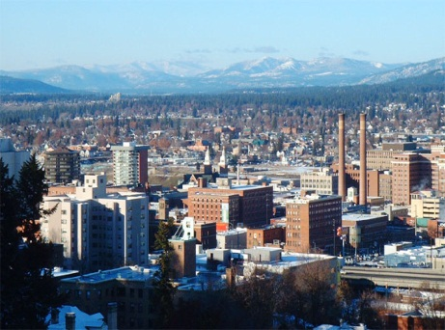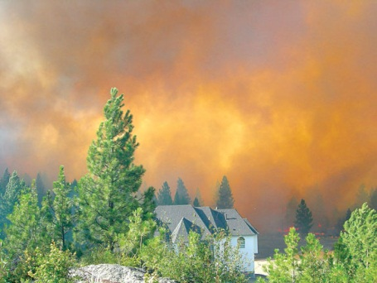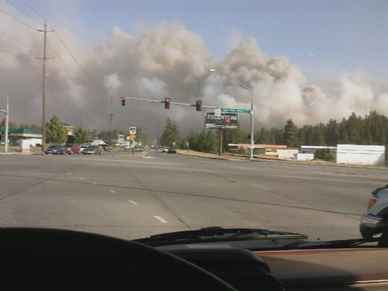

UNDERSTANDING YOUR RISK

DATE | NAME | AREA | ACRES | DEATHS
August 20, 1910 | Great Idaho Fire | Over 150,000 acres burned in Spokane, Pend Orielle Counties. | 3,000,000 | 85
1987 | Hangman Hills | 24 residences lost | 1,500 | 2
October 1991 | Firestorm 1991 | 93 fires destroyed 114 homes and 40 buildings in Ferry, Lincoln, Stevens, Pend Orielle, Spokane, and Whitman Counties. | 35,000 | 1
August 12, 1996 | Bowie Road | Spokane County | 3,000
August 14, 1997 | Newkirk/Redlake | Spokane & Stevens County | 1,750
Summer 2000 | 2000 Wildfires | Spokane, Stevens, Ferry, Whitman, Lincoln Counties | 300,000

REDUCING YOUR RISK

BEFORE
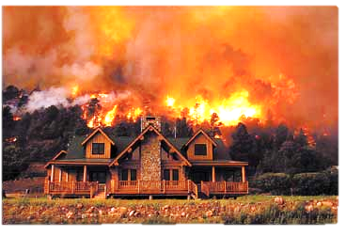
- Design and landscape your home with wildfire safety in mind. Select materials and plants that help contain fire rather than fuel it.
- Plant fire resistant shrubs and trees; Hardwood trees are less flammable than evergreen, pine, eucalyptus or fir trees.
- Regularly clean gutters and roof.
- Have your chimney cleaned and inspected at least twice a year, contact your local fire department for exact specifications regarding spark arrester installations.
- Use 1/8-inch mesh screens beneath porches, decks, floor areas and the home itself. Screen opening to floors, roof, and attic so that burning embers cannot accumulate.

DURING
- If advised to evacuate your home, do so immediately. Be sure to take your disaster supply kit, lock your home, and choose a route that travels away from the fire hazard.
- If you haven’t received evacuation orders, FEMA recommends you take the following precautions:
  - Gather fire tools such as rake, axe, handsaw/chainsaw, and shovel.
  - Close outside attic, eaves and basement vents, windows, doors and pet doors. Remove flammable drapes and curtains.
  - Shut off any natural gas or fuel supplies at the source.
  - Close all doors inside the house to prevent draft. Open the damper on your fireplace, but close the fireplace screen.

AFTER
- If you have evacuated, do not enter your home until fire officials say it is safe.
- If you remained at home, check the roof immediately after the fire danger has passed. Put out any roof fires, sparks, or embers, check the attic for any hidden burning sparks.
- Follow public health guidelines regarding safe fire ash clean up and use of masks.

For a more thorough list of Risk Reduction Recommendations, please visit: www.ready.gov

