Severe Storms

LOCAL HISTORY

All areas of Spokane County are vulnerable to severe storms and extreme winter weather annually. Affects can range from minor disruptions in transportation and utility functions to major structural damage and business closures. The best way to prevent these losses is to prepare before, during, and after severe stroms occur. As a resident of Spokane County, it is important to recognize the risks associated with your area and to start thinking about what you can do in and around your own home and local community. This handout will help you identify a variety of simple steps you can take today as well as offer multiple long-term approaches to reducing the overall risk from severe winter weather and storms.

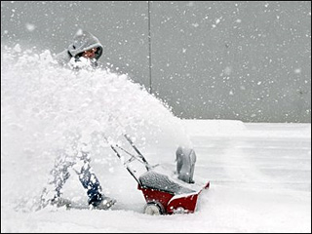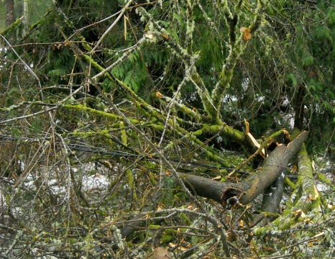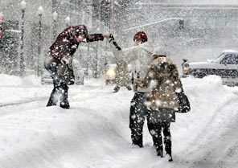

UNDERSTANDING YOUR RISK

In recent years, Spokane County has experienced severe weather in multiple forms. Windstorms occur frequently with sustained gusts of up to 50 mph. Funnel clouds may produce damaging hail, heavy rain and wind. Drifting often results from blizzards and snowstorms, leaving large amounts of snow in compact areas. Ice and hail storms can damage trees, crops, utility wires, as well as both private and public infrastructure throughout the area.

DATE | April 1972 | Nov. 1981 | Dec. 1995 | April 1996 | Nov. 1996 | Dec. 1996 | Dec .1996 | May 1997
TYPE OF STORM | Tornado | Wind | Rain, Flood, & Wind | Rain, Flood, & Wind | Ice Storm | Winter storm, Ice, Wind, & Gale Warning | Winter storm, Ice, Wind, Gale, Landslide & Avalanche | Tornado and Thunder-storm

REDUCING YOUR RISK

BEFORE
- Have a 72-hour kit prepared and ready within the home.
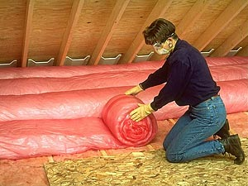
- Winterize your home by insulating walls and attics, caulking and weather-stripping doors and windows, and installing storm windows or covering windows with heavy plastic.
- Clear rain gutters, repair roof leaks, and cut away tree branches that may fall on a your house or other structures during a storm.
- Inspect the structural ability of your roof to sustain heavy accumulations of snow, water, or ice--you may need to consult a contractor.
- Know how to operate and shut off water valves (in case pipes burst); maintain heating equipment and chimneys by having them cleaned and inspected annually.

DURING
- Stay indoors during the storm; drive only if absolutely necessary and keep someone informed of your destination and time of travel.
- Keep dry. Change wet clothing frequqently to prevent loss of body heat.
- Know and watch for signs of frostbite, hypothermia, and overexertion.
- If the pipes freeze, remove any insulation or layers of newspapers and wrap pipes in rags. Completely open all faucets and and pour hot water over the pipes, starting where they were most exposed to the cold.
- If you will be going away during cold weather, leave the heat on in your home, set to a temperature of at least 55°F.

AFTER
- Go to a designated public shelter if your home loses power during periods of extreme cold.
Text: SHELTER + your ZIP code to 43362 (FEMA) to find the nearest shelter in your area. Example: shelter 99202
- Continue to protect yourself from frostbite and hypothermia by wearing warm, loose-fitting, light-weight clothing in several layers.
- Stay indoors as much as possible, until the weather has subsided enough to be out.

For a more thorough list of Risk Reduction Recommendations, please visit: [www.ready.gov]

