Preparing your Home for Wildfire

In order to make your home as defensible as possible against wildfire risk, there are a host of measures that can be taken. This list is not exhaustive, but does provide a number of safety measures to better protect your property during fire season. It is recommended that you create a 30 to 100 foot safety zone around your home. Within this area, you can take steps to reduce potential exposure to flames and radiant heat. Homes built within pine forests should have a minimum safety zone of 100 feet. If your home sits on a steep slope, additional safety precautions should be taken. Contact your local fire department or forestry service for additional information.

- Rake leaves, dead limbs and twigs. Clear all flammable vegetation.
- Remove leaves and rubbish from under structures.
- Thin a 15-foot space between tree crowns, and remove limbs within 15 feet of the ground.
- Remove dead branches that extend over the roof.
- Prune tree branches and shrubs within 15 feet of a stovepipe or chimney outlet.
- Ask the power company to clear branches from powerlines.
- Remove vines from the walls of the home.
- Mow and water grass regularly, it should be no more than 6 icnhes tall at any given time.
- Clear a 10-foot area around propane tanks and the barbecue. Place a screen over the grill - use nonflammable material with mesh no coarser than one-quarter inch.
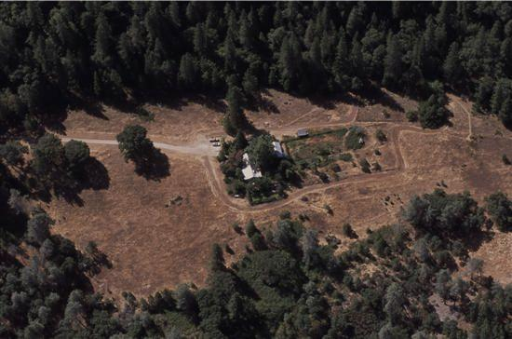
- Regularly dispose of newspapers and rubbish at an approved site. Follow local burning regulations.
- Place stove, fireplace and grill ashes in a metal bucket, soak in water for 2 days; then bury the cold ashes in mineral soil.
- Store gasoline, oily rags and other flammable materials in approved safety cans. Place cans in a safe location away from the base of buildings.
- Stack firewood at least 100 feet away and uphill from your home. Clear combustible material within 20 feet. Use only wood-burning devices evaluated by a nationally recognized laboratory, such as Underwriters Laboratories (UL).

