Floods

LOCAL HISTORY

Floods are a common natural disaster in Spokane County, some even resulting in local and federal disaster declarations in recent years. Several bodies of water in the County flood every two to five years, including the Spokane and Little Spokane Rivers, and Latah Creek, causing concern for residents who live both inside and out of the floodplain. Floods have the potential to contaminate domestic water supplies, foul septic systems, inundate electrical and heating systems, and even cause groundwater to rise and seep into basements or low-lying structures. If floodwaters maintain a high enough level, they may restrict access to certain roads or neighborhoods, preventing emergency responders from reaching residents in times of crisis. The following information will help you identify a variety of simple steps you can take today as well as offer multiple long-term approaches to reducing the overall risk from flooding.

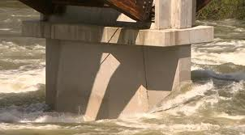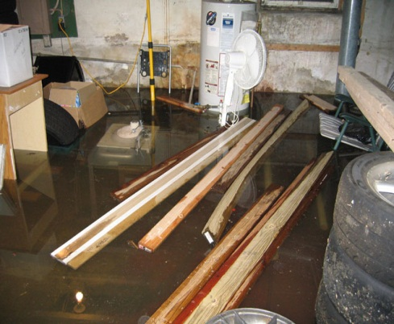

UNDERSTANDING YOUR RISK

DATE | OCCURRENCE
March 1963 | Flooding occurred in the counties of Columbia, Garfield, Grant, Whitman, and Spokane. Federal disaster number 146 was assigned for the event.
February 1996 | Heavy rains caused flooding in several counties including Spokane. Snowfall beginning January 26, 1996, followed by heavy rain February, mild temperatures, and mountain snow melt caused severe flooding throughout the entire northwest. Record floods occurred on Latah Creek. Federal disaster number 1100 was assigned for the event.
December 1996 – January 1997 | Rain, ice, and snow caused flooding. Federal disaster number 1159 was assigned for several counties including Spokane. The town of Rockford experienced damage to 11 buildings with their sanitary sewer line and streets sustaining $367,860 worth of damage.

This table is not exhaustive, but provides a small glimpse of what flood damage can look like in Spokane County.
REDUCING YOUR RISK

BEFORE
- Know your local flood risk. Is your home or business located within a floodplain? Are you prepared structurally and/or financially to cope with losses due to flood?
- Determine if your level of risk makes purchasing flood insurance feasible.
- Build a disaster kit and have a family communication plan in place.
- Elevate the furnace, water heater and electrical panel in your home; consider installing “check valves” to prevent floodwater from backing up into the drains.
- Construct barriers to stop floodwater from entering the building and seal walls in basements with waterproofing compounds.

DURING
- Be aware that flash flooding can occur. If there is any possibility of a flash flood, immediately move to higher ground, do not wait for instructions to do so.
- Streams, drainage channels, canyons and other areas are known to flood suddenly and can occur with or without typical warning signs such as rain clouds or heavy rain.
- If you must prepare to evacuate:
  - Secure your home. If you have time, bring in outdoor furniture. Take essential items to the highest floor.
  - Turn off utilities at the main switches or valves; disconnect electrical appliances; DO NOT tough electrical equipment if you are wet or standing in water.
  - When evacuating, do not move through moving water. Six inches of moving water can cause you to fall, walk where the water is most calm.

AFTER
- Stay away from damaged areas unless your assistance has been specifically requested by police, fire, or relief organization. Only return to your home when authorities identify it as safe to do so.
- Roads may still be closed because they have been damaged or are covered by water. If you come across a barricade, choose an alternate route.
- Be aware of areas where floodwaters have receded. Roads may have weakened and could collapse under the weight of your car.
- Use extreme caution when entering buildings; there may be hidden damage, particularly in foundations.
- Stay out of any building if it is surrounded by floodwaters.

For a more thorough list of Risk Reduction Recommendations, please visit: www.ready.gov

