Earthquake s

LOCAL HISTORY

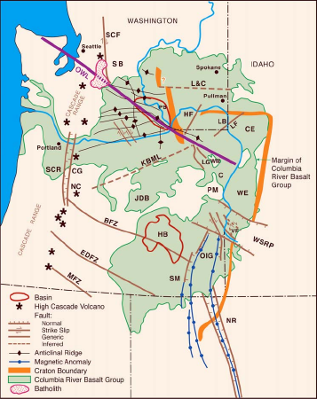
The State of Washington ranks second in the nation after California among states vulnerable to earthquake damage. Earthquake activity within the eastern side of the state can be classified as low probability, high risk events. Spokane County has experienced a range of low-magnitude events, most recently a small series back in 2001. The County’s people, buildings, emergency services, hospitals, transportation, dams, and electric, natural gas, water, and sewer utilities are all susceptible to major earthquake damage and/or interference. The following information will help you identify a variety of simple steps you can take today as well as some long term approaches to reducing the overall risk from earthquakes.

Other Considerations:
- Do you own a business?
- Are you a childcare provider?
- What is your work environment?
- Are you a prepared homeowner?
- Do you have pets to consider?

UNDERSTANDING YOUR RISK

YEAR | LOCATION | LOSSES
1872 | Lake Chelan, WA | Not Available
1936 | Walla Walla, WA | $100,000
1939 | Hebgen Lk, MT | 28 deaths; $11,000,000
1983 | Borah Peak, ID | Not Available
2001 | Spokane, WA | Not Available
Regionally, there is a long history of earthquakes. The table to the right lists a portion of these earthquakes with estimated economic losses where available. It is important to remember that even though the quake may not occur directly in the County, the physical, financial, and emotional reporcusions may still be felt at a local level. Neighboring communities may call on Spokane County for additional resources, communication facilities, and sheltering needs in times of crisis. The higher probability of earthquakes in Western Washington makes it likely that Spokane County could serve as a place for holding casualties as well as migrants from the west.
REDUCING YOUR RISK

BEFORE

- Fasten shelves and bookcases securely to walls. Fasten heavier items such as mirrors and pictures away from beds, couches, and anywhere people sit.
- Place large or heavey objects on lower shelves; store breakable items such as bottled foods, glass and china in low, closed cabinets with latches.
- Install flexible pipe fittings to avoid gas or water leaks. Flexible fittings are more resistant to breakage.
- Repair any deep cracks in any ceilings or foundations.
- Be sure the residence is firmly anchored to its foundation.
- Hold earthquake drills with your family members: Drop, Cover, and Hold On.

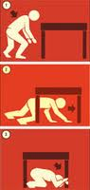
DURING

- DROP to the ground; take COVER by getting under a sturdy table or other piece of furniture; and HOLD ON until the shaking stops.
- Stay away from glass, windows, outside doors and walls, and anything that could fall, such as lighting fixtures or furniture.
- Be aware that the electicity may go out or the sprinkler systems or fire alarms may turn on.
- DO NOT use the elevator.
- Stay inside until the shaking stops and it is safe to go outside. Do not exit a building during the shaking.

AFTER

- Expect aftershocks.
- Look for and extinguish small fires. Fire is the most common hazard after an earthquake.
- Inspect utilities. Check for gas leaks, electrical system damage, and any damage to sewer and/or water lines. Enlist the help of a professional if noticeable damage is visible.
- Be careful when driving after an earthquake; anticipate traffic light outages.
- Go to a designated public shelter if your home has been damaged and is no longer safe. Text: SHELTER + your ZIP code to 43362 (FEMA) to find the nearest shelter in your area. Example: shelter 99202

For a more thorough list of Risk Reduction Recommendations, please visit: www.ready.gov
Contact FEMA Region X:

