Developing a Home for Wildfires

Developers play an important role in determining a home’s resistance to wildfires. All phases of the construction process, from planning to implementation, can have a significant impact during any wildfire event. Aspects to be considered include location, building materials, and complying with Firewise standards. For more information, contact your local fire department or firewise.org.

Pre-Construction Design
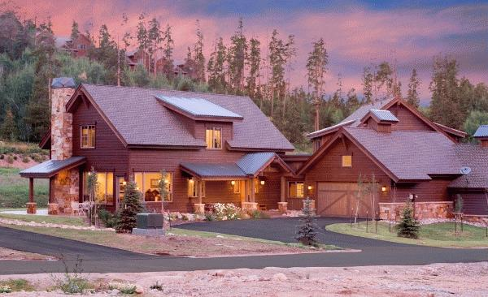
- Choose a site away from heavily vegetated areas.
- Build on the most level portion of the property.
- Avoid ridgetops, canyons and areas between high points on a ridge. These are extremely hazardous locationsfor houses and fire-fighters because they become natural chimneys, increasing the intensity of the fire.
- Design decks so that they are not located at the top of a hill directly in the line of a fire moving up slope.

Building Materials & Considerations
- Use fire-resistive or non-combustible building materials. Whenever possible, use brick, rock, or stucco—they resist fire much better than wood.
- Your roof has the largest surface area of your structure and is also the most vulnerable, exposed exterior of your house. Use class A or B roofing materials, such as asphalt shingles, slate or clay tile, or metal.
- Use a minimum of Class III flame-spread rated siding material, from the ground to the roof overhang.
- A building’s foundation often comes in contact with wildfire first, enclose them with concrete block, cement walls, or other fire-resistive building materials.
- Minimize the size and number of windows on the downhill side of the house or the side that would most likely be exposed to wildfire. Consider both size and material for not only windows but sliding glass doors. Multi-paned glass provides more protection from radiant heat than single-paned.
- To prevent spark and embers from entering your home, cover attic and vent spaces with 1/8-inch wire mesh.
- Install eave and soffit vents closer to the roof line than the walls.

