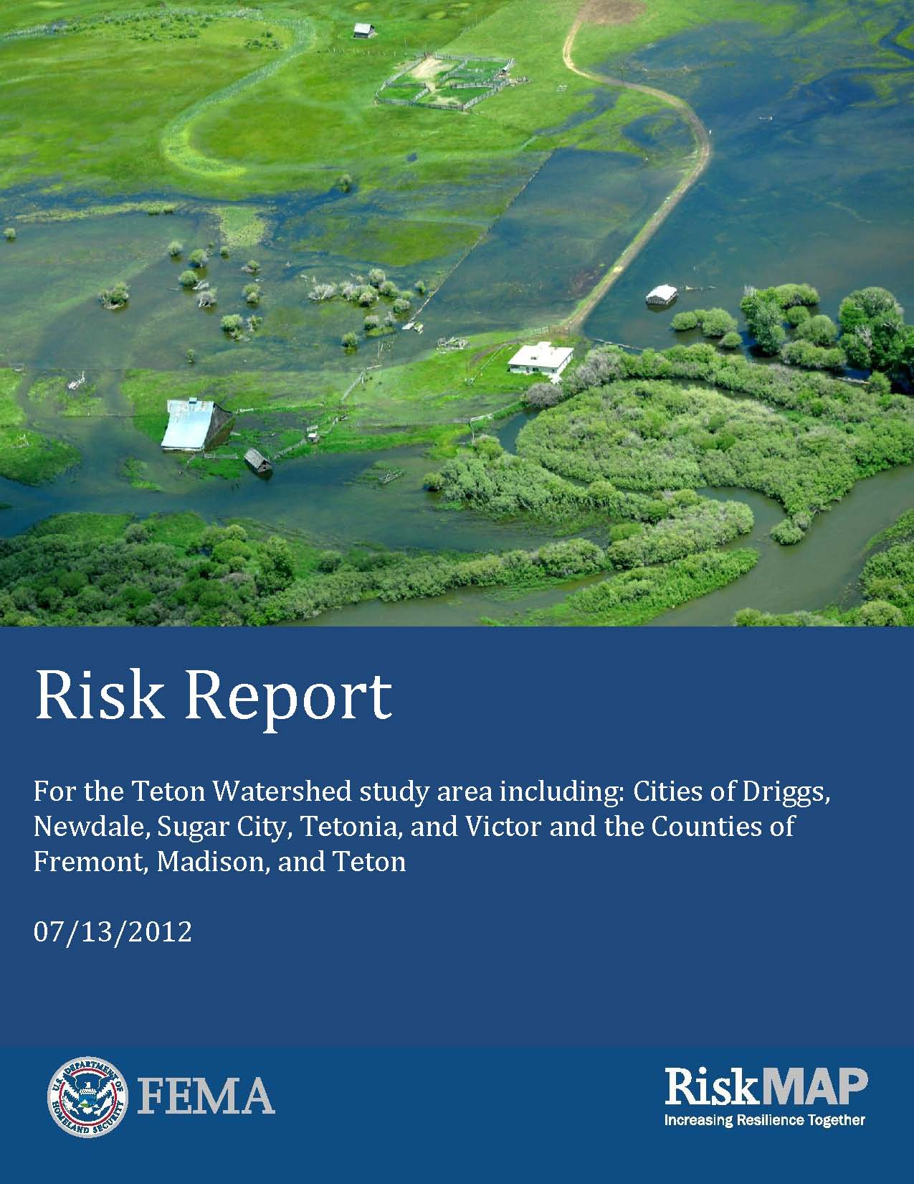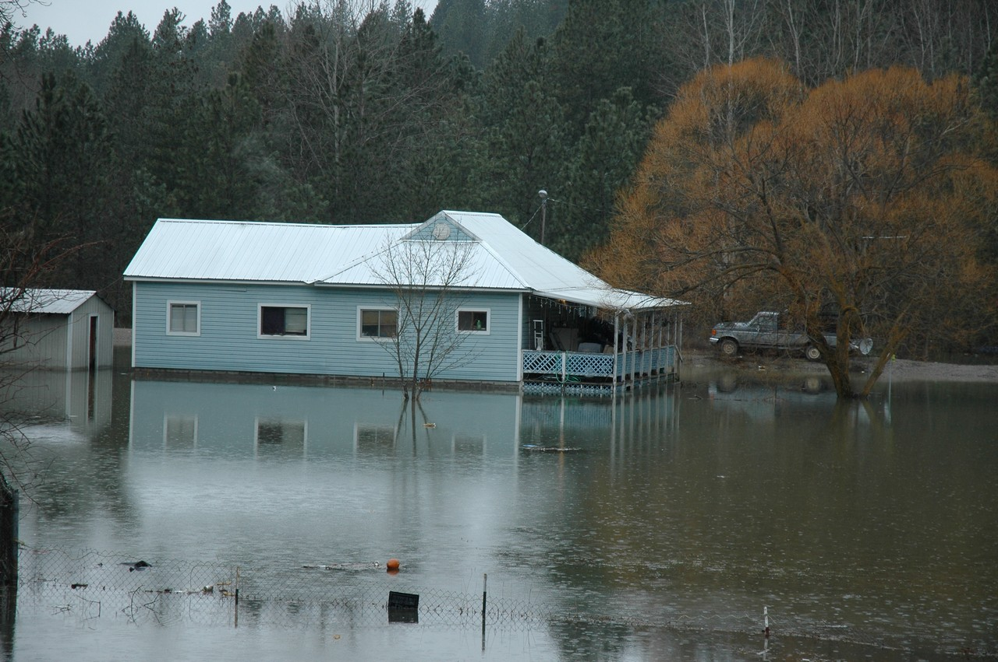

Risk Report

This Risk Report covers the Upper Spokane Watershed study area and is specific to Kootenai County and its participating communities: The Cities of Post Falls, Coeur d’Alene, Hayden Lake, Hayden, Rathdrum, and Dalton Gardens; and Kootenai County.

DRAFT October 2012

# Preface

The Department of Homeland Security (DHS), Federal Emergency Management Agency’s (FEMA) Risk Mapping, Assessment, and Planning (Risk MAP) program provides States, Tribes and local communities with flood risk information and tools that they can use to increase their resilience to hazards and better protect their citizens. By combining accurate maps with risk assessment tools and planning and outreach support, Risk MAP has transformed traditional flood mapping efforts into an integrated process of identifying, assessing, communicating, planning for, and mitigating risks.

This Risk Report provides non-regulatory information to help local or Tribal officials, floodplain managers, planners, emergency managers, and others better understand their risk, communicate those risks to their citizens and local businesses, and take steps to mitigate those risks.

Because the extent of a risk often extends beyond community limits, the Risk Report provides risk data for the entire study area as well as for each individual community when available. This also emphasizes that risk reduction activities may impact areas beyond jurisdictional boundaries.

The risk associated with hazards is always changing, and there may be other studies, reports, or other sources of information available that provide more comprehensive information. The Risk Report is not intended to be regulatory or the final authoritative source of all risk data in the project area. Rather, it should be used in conjunction with otherdata sources to provide a comprehensive picture of flood, seismic, wildfire, landslides, and severe weather risks and their effects within the project area.

# Table of Contents

Preface iii

Table of Contents iv

1. Introduction 1

1.1 About Flood Risk 1

1.2 About Earthquake Risk in Eastern Washington and Northwestern Idaho 2

1.3 About Severe Weather Risk 4

1.4 Uses of this Report 4

2. Risk Analysis 6

2.1 Flood Overview 6

2.2 Analysis of Flood Risk 6

2.3 Flood Depth Grids 7

2.4 Seismic Overview 7

2.5 Analysis of Seismic Risk 8

2.6 ShakeMaps 8

2.7 Hazus Estimated Loss Information 8

2.8 Areas of Mitigation Interest (AOMI) 10

3. Flood Risk Analysis Results 11

3.1 Upper Spokane Watershed Summary 11

3.2 City of Coeur d’Alene Summary (CID 160078) 14

3.3 City of Dalton Gardens (CID 160164) 16

3.4 City of Hayden Summary (CID 160170) 18

3.5 City of Post Falls (CID 160083) 20

3.6 City of Rathdrum (CID 160083) 22

3.7 Kootenai County Incorporated and Unincorporated Areas (CID 160076) 24

4. Earthquake Risk Analysis Results 27

4.1 United States Geologic Survey (USGS) Scenario ShakeMap 27

5. Wildfire Risk Overview 29

5.1 Wildfire Overview 29

5.2 Fire Regime Condition Class (FRCC) 29

5.3 Data Gap 31

5.4 West Wide Wildfire Risk Assessment (WWA) 32

5.5 References 33

6 Actions to Reduce Risk 34

6.1 Types of Mitigation Actions 34

6.2 Identifying Specific Actions for your Community 37

6.3 Mitigation Programs and Assistance 38

Appendix A: Acronyms and Definitions

Appendix B: Additional Resources

Appendix C: First Pass Analysis

Appendix D: Upper Spokane Watershed Outreach Handouts

# Introduction

**Which picture below shows greater flood risk?**

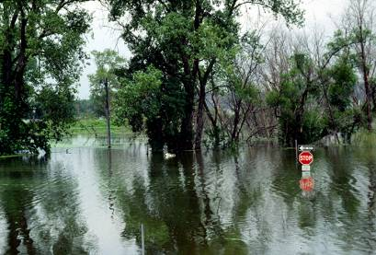

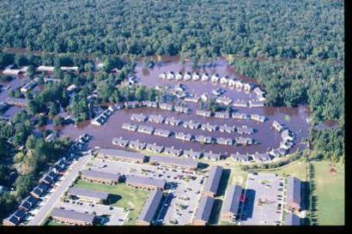

Even if you assume that the flood in both pictures was the same probability (e.g. a 10% annual-chance flood) the consequences in terms of property damage and potential injury as a result of the flood in the bottom picture are much more severe. Therefore, the flood risk in the area shown on the bottom picture is greater.

## About Flood Risk

Floods are naturally occurring events that can and do happen almost anywhere. In its most basic form, a flood is an accumulation of water over normally dry areas. Floods become hazardous to people and property when they inundate an area where development has occurred, causing losses.

***Which picture below shows more flood risk?***

**

**

*Even if you assume that the flood in both pictures was the same probability- let’s say a 10%-percent- annual-chance flood -- the consequences in terms of property damage and potential injury as a result of the flood in the bottom picture are much more severe. Therefore the flood risk in the area shown on the bottom picture is higher.*

***Which picture below shows more flood risk?***

**

**

*Even if you assume that the flood in both pictures was the same probability- let’s say a 10%-percent- annual-chance flood -- the consequences in terms of property damage and potential injury as a result of the flood in the bottom picture are much more severe. Therefore the flood risk in the area shown on the bottom picture is higher.*

Calculating Flood Risk

The most common method for determining flood risk, also referred to as vulnerability, is to identify the probability of flooding and the consequences of flooding:

**Flood Risk** (or Vulnerability) **= Probability x Consequences**; where

**Probability** = the likelihood of occurrence

**Consequences** = the estimated impacts associated with the occurrence

* The probability of a flood is the likelihood that a flood will occur. The probability of flooding can change based on physical, environmental, and/or engineering factors. Factors affecting the probability that a flood will impact an area vary due to changing weather patterns, land use decisions, to the existence of mitigation projects. The ability to assess the probability of a flood, and the level of accuracy for that assessment, is also influenced by modeling methodology advancements, better knowledge, and longer periods of record for the water body in question.
* The consequences of a flood are the estimated impacts associated with the flood occurrence. Consequences relate to humans activities within an area and how a flood impacts the natural and built environment.

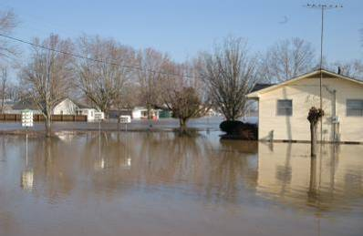

Whether an area might flood is one consideration. The extent to which it might flood adds a necessary dimension to that understanding**.**

Risk MAP Flood Risk Products

FEMA understands that flood risk is dynamic and that flooding does not stop at a line on a map, and provides the following flood risk products:

* A section in the Risk Report that describes key findings.
* A Flood Risk Map, found in Section 3.1 of this document, shows risk areas at risk and is provided asan exhibit within the Risk Report. Details about the data shown on the map can be found in Section 2.
* A Flood Risk Database houses the flood risk data developed during the course of the flood risk analysis to the raw flood risk data that can be used and updated by the community. After the Risk MAP study is complete, this data can be used in many ways to visualize and communicate flood risk within the study area.

## About Earthquake Risk in Eastern Washington and Northwestern Idaho

Idaho and Washington have active faults that have produced a number of historic earthquakes.

The U.S. Geological Survey (USGS) National Seismic Hazard Maps display earthquake ground motions for various probability levels across the United States and are applied in seismic provisions of building codes, insurance rate structures, risk assessments, and other public policy. This is updated periodically to incorporate new findings on earthquake ground shaking, faults, seismicity, and geodesy. The resulting maps are derived from seismic hazard curves calculated on a grid of sites across the United States that describe the frequency of exceeding a set of ground motions. Below is a figure of the 2008 USGS Hazard Map with a 2% in 50 year probability.

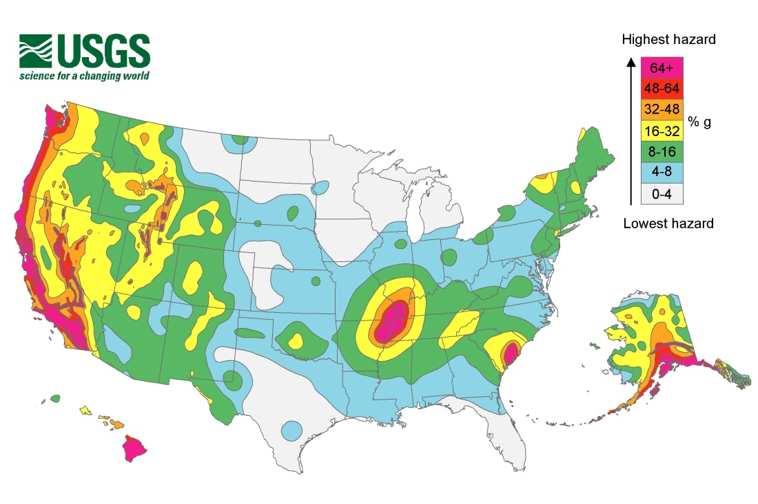

Calculating Earthquake Risk

Earthquake risk is calculated based on location, extent, and magnitude. Location is determined by locations of faults and/or past locations of earthquakes. Extent and magnitude are measured in two ways:

* Magnitude (as measured by the Richter Scale) measures the energy that is released. Magnitude is calculated by seismologists from seismograph readings and is most useful to scientists comparing the power of earthquakes.
* Intensity (as measured by the Modified Mercalli Intensity Scale, MMI). The Modified Mercalli Intensity Scale is a subjective description of the physical effects of the shaking based on observations at the event site. Using this scale, a value of I is the least intense motion, and XII is the greatest ground shaking. Unlike magnitude, intensity can vary from place to place.

|  |
| --- |
| **Modified Mercalli Intensity Scale (MMI)** |
| **I.** Not felt except by a very few under especially favorable conditions  Examples of how FEMA data can be leveraged to identify and measure vulnerability. |
| **II.** Felt only by a few persons at rest, especially on upper floors of buildings |
| **III.** Felt quite noticeably by persons indoors, especially on upper floors of buildings. Many people do not recognize it as an earthquake. Standing motor cars may rock slightly. Vibrations similar to the passing of a truck. Duration estimated. |
| **IV**. Felt indoors by many, outdoors by few during the day. At night, some awakened. Dishes, windows, doors disturbed; walls make cracking sound. Sensation like heavy truck striking building. Standing motor cars rocked noticeably. |
| **V.** Felt by nearly everyone; many awakened. Some dishes, windows broken. Unstable objects overturned. Pendulum clocks may stop. |
| **VI.** Felt by all, many frightened. Some heavy furniture moved; a few instances of fallen plaster. Damage slight. |
| **VII.** Damage negligible in buildings of good design and construction; slight to moderate in well-built ordinary structures; considerable damage in poorly built or badly designed structures; some chimneys broken. |
| **VIII.** Damage slight in specially designed structures; considerable damage in ordinary substantial buildings with partial collapse. Damage great in poorly built structures. Fall of chimneys, factory stacks, columns, monuments, walls. Heavy furniture overturned. |
| **IX.** Damage considerable in specially designed structures; well-designed frames structures thrown out of plumb. Damage great in substantial buildings, with partial collapse. Buildings shifted off foundations. |
| **X.** Some well-built wooden structures destroyed; most masonry and frame structures destroyed with foundations. Rails bent. |
| **XI.** Few, if any (masonry) structures remain standing. Bridges destroyed, Rails bent greatly. |
| **XII.** Damage total. Lines of sight and level are distorted. Objects thrown into the air. |

**Risk MAP Earthquake Risk Products**

* A section in the Risk Report that describes key findings.
* A profile of available USGS ShakeMaps that may impact the study area.
* An Earthquake Risk Database that houses the earthquake risk data during the course of the risk assessment that can be used and updated by the community.

## About Severe Weather Risk

Kootenai’s weather is typified by a very warm, arid climate during the summer months and a cold, snowy, and moist climate during winter months. Kootenai’s location between the Cascade Mountains to the west and Rocky Mountains to the east and north, protects the area from typical weather patterns found in other regions of the Pacific Northwest. The area does experience ice storms and high wind storms that can impact the region for days to weeks. Typical storm damages include power outages, infrastructure collapse, and snowdrifts that block typical travel patterns.

Kootenai County maintains a hazard warning system that supplements warning services provided by the National Weather Service, NOAA Weather Radio, and other local, state, and federal agencies. The warning system can utilize both public and private resources, to the extent practicable, and activate at the neighborhood, community, or county level. Winter storm safety and preparedness checklists are located on the Kootenai County Office of Emergency Management website. In addition to this information, an outreach handout has been prepared by FEMA and is available in Appendix D of this report that discusses the local history of severe storms and steps residents can take before, during, and after a severe storm event.

## Uses of this Report

The goal of this report is to help inform and enable communities to take action to reduce risk. State, local, and tribal officials can use the summary information provided in this report, in conjunction with the data in the Risk Database, to:

* **Update local hazard mitigation plans and community comprehensive plans** – Planners can use risk information in the development and/or update of hazard mitigation plans, comprehensive plans, future land use maps, and zoning regulations. For example, zoning codes may be changed to better provide for appropriate land uses in high hazard areas.
* **Update emergency operations and response plans** – Emergency managers can identify low risk areas for potential evacuation and sheltering, and can assist first responders in avoidance of areas of high risk areas. Risk assessment results may show vulnerable areas, facilities and infrastructure for which planning for continuity of operations plans (COOP), continuity of government (COG) plans, and emergency operations plans (EOP) would be essential.
* **Communicate risk** – Local officials can use the information in this report to communicate with property owners, business owners, and other citizens about risks and what can be done about it.
* **Inform the modification of development standards** – Floodplain and emergency managers, planners and public works officials can use information in this report to support the adjustment of development standards for certain locations. For example, heavily developed areas tend to increase floodwater runoff because paved surfaces cannot absorb water, indicating a need to adopt or revise standards that provide for appropriate stormwater retention.

The risk products provided under Risk MAP are available and intended for community use. They are not tied to the regulatory development and insurance requirements of the National Flood Insurance Program nor are they required to be used.

Possible users of this report include—

* Local Elected Officials
* Floodplain Managers
* Community Planners
* Emergency Managers
* Public Works Officials
* Other Special Interests (e.g., watershed conservation groups, environmental awareness organizations, etc.)

# Risk Analysis

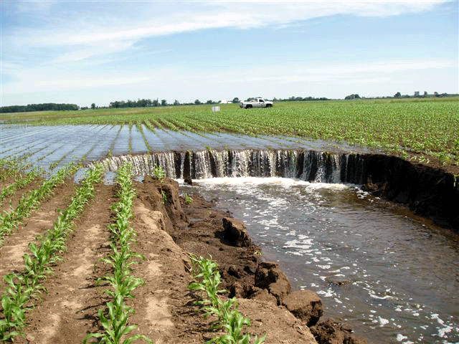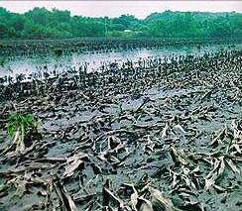

Flooding impacts non-populated areas too, such as agricultural lands and wildlife habitats.

***.***

## Flood Overview

Risk assessment is the systematic approach to identifying how a hazard impacts the environment. By defining the hazard, flood risk assessments enable informed decision making and form the basis for mitigation strategies and actions. To fully assess flood risk requires the following:

* Development of a complete profile of the flood hazard including location, historical occurrence and previous impacts
* Inventory of assets located in the identified flood hazard area
* Estimation of potential future flood losses caused by exposure to the area of flood hazard

Flood risk analysis can be done on a large scale (state, watershed) level and on a very small scale (parcel, census block). Large scale flood risk analysis can identify how actions and development in one community can affect areas up- and downstream. On the parcel or census block level, analysis can provide communities with actionable data to inform appropriate mitigation actions.

## Analysis of Flood Risk

To assess potential community losses or the consequences portion of the “risk,” equation, the following data was collected:

State and Local Hazard Mitigation Plans are required to have a comprehensive all-hazard risk assessment. The flood risk analyses in the FRR, FRM, and FRD can inform the flood hazard portion of a community’s or state’s risk assessment. Further, data in the flood risk database can be used to develop information which meets the requirements for risk assessments as it relates to the hazard of flood in hazard mitigation plans*.*

* Information about local assets or resources at risk of flooding
* Information about the physical features and human activities that contribute to that risk
* Information about location and severity of the hazard

The report, maps and database contain three general types of risk analysis to help describe and visualize the flood risk at the jurisdictional levels:

1. Water Surface, Flood Depth and Analysis Grids
2. Hazus Estimated Loss Information
3. Areas of Mitigation Interest

## 2.3 Flood Depth Grids

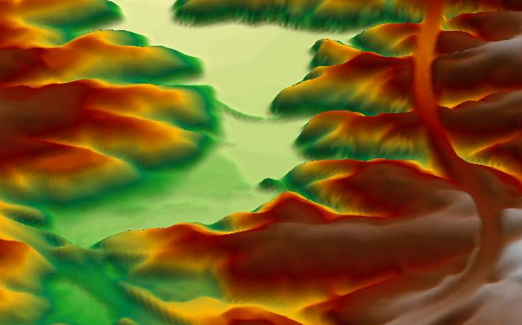

**XS**

XS

Depth

Depth grids are FEMA datasets provided in the Risk Report. Depth grids help to understand not only where the water will go but how deep it can get. These grids are intended to be used by communities for additional analysis, enhanced visualization, and communication of flood risks for hazard mitigation planning and emergency management. Grids provided in the Risk Report for this project area include 10%, 2%, 1%, and .2% Flood Depth Grids. The multi-frequency flood depth and analysis grids show depth, which is calculated as the difference (in feet) between the water surface elevation and the ground. These depth grids are used to calculate potential flood losses.

## 2.4 Seismic Overview

Risk assessment is the systematic approach to identifying how a hazard impacts the environment. By defining the hazard, earthquake risk assessments enable informed decision making and form the basis for mitigation strategies and actions. To fully assess earthquake risk requires the following:

* Development of a complete profile of the seismic hazard including epicenter, depth, magnitude, shaking intensity, liquefaction and soil data.
* Inventory of assets located in the identified hazard area
* Estimation of potential future losses caused by exposure to the area of the hazard.

Earthquake analysis is done on a large scale (state, county, watershed) level. Large scale risk analysis can identify how infrastructure capabilities, capacity, and failures can affect neighboring and distant community’s economy and response efforts.

## 2.5 Analysis of Seismic Risk

To assess potential community losses or the consequences portion of the “risk,” equation, the following data was collected:

* Information about local assets or resources that may be damaged by lateral ground movement and/or liquefaction,
* Information about the physical features (i.e. bridges, overpasses, etc.),
* Human activities that contribute to that risk (i.e. shelter needs, etc.) and information about location and severity of the hazard. The report, maps, and database contain two general types of risk analysis to help describe and visualize earthquake risk at the watershed level:

1. Shaking Intensity and liquefaction overlays
2. Hazus Estimated Loss Information

## 2.6 ShakeMaps

A ShakeMap is created by regional seismic network operators in cooperation with the United Geologic Survey (USGS). ShakeMaps can provide near real-time maps of shaking intensity and ground motion following an earthquake. ShakeMaps can also be generated as “Earthquake Scenarios” where intensities and ground motions have been estimated. These are events on faults that have ruptured in the past or have a likelihood of rupturing in the future. The primary purpose of a ShakeMap is for emergency response exercises and planning as well as for understanding the potential consequences of future large earthquakes. This data can be used as hazard scenario input for a FEMA loss-estimation tool, HAZUS, providing the software with seismic intensity and ground motions data for use in more accurately depicting losses.

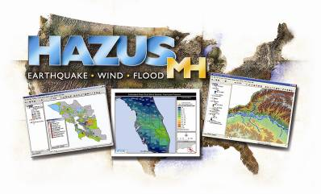

HAZUS-MH is a loss estimation methodology developed by FEMA for the flood, wind, and earthquake hazards. The methodology and data established by HAZUS can also be used to study other hazards.

## 2.7 Hazus Estimated Loss Information

Loss estimates provided in the Risk Report were developed using a FEMA risk assessment tool, Hazus-MH. Hazus is a tool that can help to estimate losses to lives and property by combining information about the built environment with information about the location and magnitude of hazard. Hazus can provide risk assessment information for floods, earthquakes, and hurricane winds.

The Risk Report primarily uses specific flood and seismic risk analysis methods which are summarized below:

**Scenario Loss Estimates:**

* **Flood:** Scenario losses have been generated by Hazus for the 10%, 2%, 1% and 0.2% floods.
* **Seismic:** A 5.5M earthquake in Spokane was input into Hazus.

Loss estimates are based on best available data, and the methodologies applied result in an approximation of risk. These estimates should be used to understand relative risk and potential losses. Uncertainties are inherent in any loss estimation methodology, arising in part from approximations and simplifications that are necessary for a comprehensive analysis (e.g., incomplete inventories, demographics, or economic parameters).

A typical Risk Report would report contains Hazus estimated losses for the following: (Refer to the Earthquake Risk Analysis Results Section for more detailed information on Hazus outputs for Kootenai County)

* **Residential Asset Loss** – These include direct building losses (estimated costs to repair or replace the damage caused to the building) for all classes of residential structures including single family, multi-family, manufactured housing, group housing, and nursing homes. This value also includes content losses.
* **Commercial Asset Loss** –These include direct building losses for all classes of commercial buildings including retail, wholesale, repair, professional services, banks, hospitals, entertainment, and parking facilities. This value also includes content and inventory losses.
* **Other Asset Loss** –This includes losses for facilities categorized as industrial, agricultural, religious, government, and educational. This value also includes content and inventory losses.

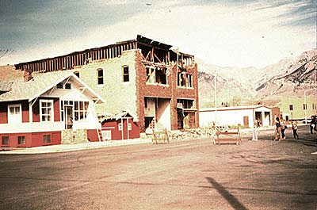

Unreinforced masonry buildings are susceptible to shaking and create debris.

* **Potential Impact to Essential Facilities**- including hospitals, fire stations, police stations, Emergency Operation Centers and schools
* **Shelter needs**-Projected number of people displaced from residence and/or in need of shelter
* **Debris**-Projected amount of debris generated in tons
* **Loss Ratio:** The loss ratio expresses the scenario losses divided by the total building value for a local jurisdiction. This can be a gage to determine overall community resilience as a result of a scenario event. For example, a loss ratio of 5% for a given scenario would indicate that a local jurisdiction would be more resilient and recover easier from a given event versus a loss ratio of 75% which would indicate widespread losses.
* **Hazus Flood Risk Value:** On the Flood Risk Map, relative flood risk is calculated at the community level and is expressed by the following three categories: low, medium, and high. It is based on the 10%, 2%, 1%, and .2% return periods and is calculated at the census block.

## Areas of Mitigation Interest (AOMI)

Many factors contribute to flooding and flood losses. Some are natural, some are not. In response to these risks there has been a focus by the Federal Government, State agencies, and local jurisdictions to avoid losses and mitigate properties against the impacts of flood hazards. AOMIs are important to identifying target areas and potential projects for flood hazard mitigation, encouraging local collaboration, and communicating how various mitigation activities can successfully reduce flood risk.

A list of hazard specific mitigation actions for each AOMI can be found in section 5.

# 3. Flood Risk Analysis Results

The following pages provide general risk assessment results of the analyses and identified areas of mitigation interest at the watershed level within Kootenai County as well as detailed results at the community level.

## 3.1 Upper Spokane Watershed Summary

**Watershed Overview Map**

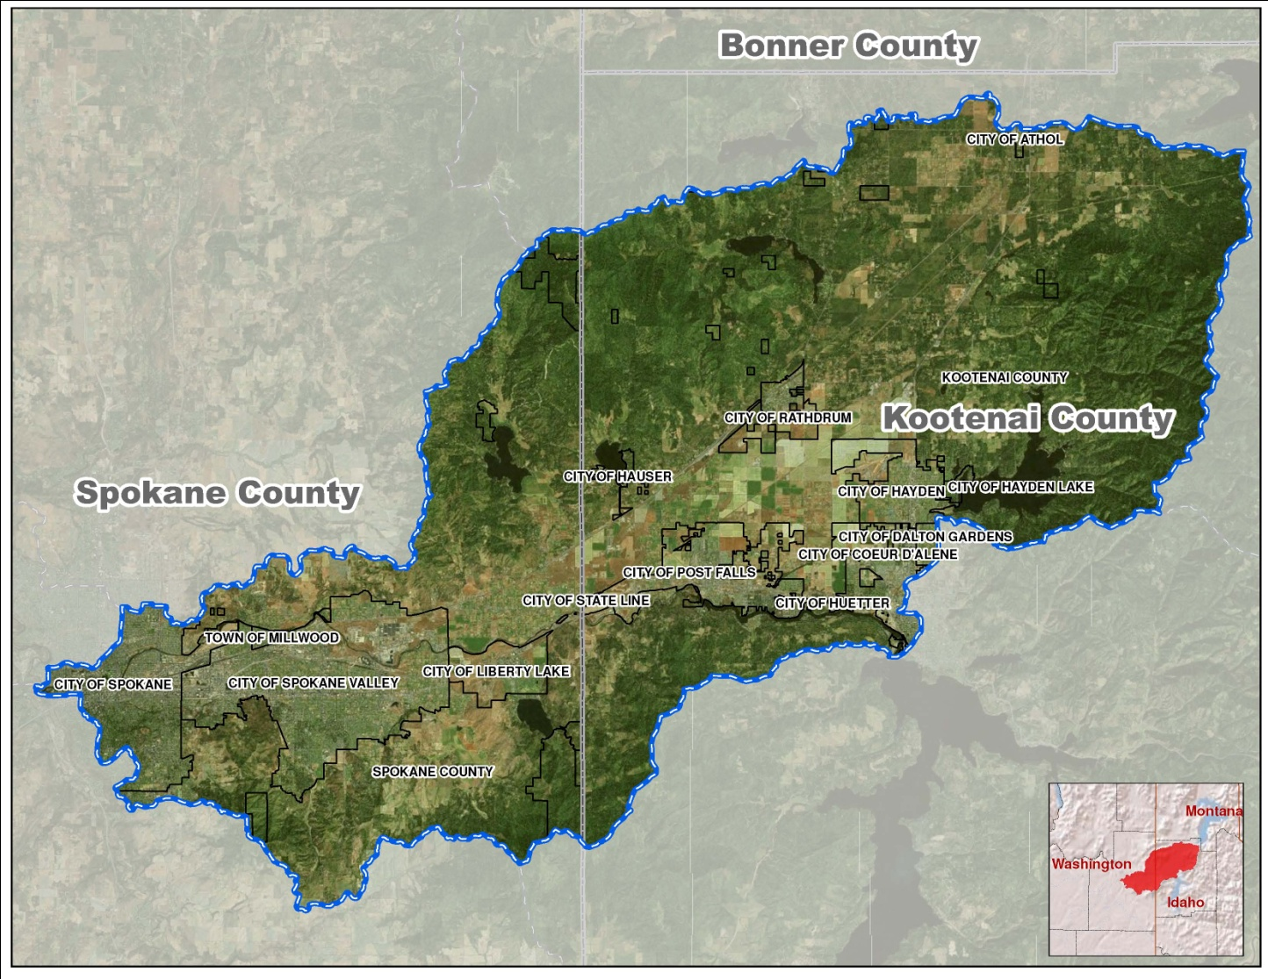

Source: Kootenai and Spokane Counties

Kootenai County, within the Upper Spokane Watershed, includes the following communities:

|  |  |  |  |  |  |  |  |  |
| --- | --- | --- | --- | --- | --- | --- | --- | --- |
| **Community Name** | **CID** | **Total Community Population** | **Environmental Sensitive Issues** | **CRS Community** | **Flood Claims** | **Repetitive Loss Properties** | **Total Policies** | **Total Insurance Coverage** |
| Coeur d’Alene | 160078 | 44,137 | Aquifer | No | 0 | 0 | 41 | $8,488,900 |
| Dalton Gardens | 160164 | 2,335 | Aquifer | n/a | n/a | n/a | 1 | $350,000 |
| Hayden | 160170 | 13,294 | Aquifer | No | 0 | 0 | 4 | $1,008,000 |
| Post Falls | 160083 | 27,574 | Q’emiln Park & Aquifer | No | 0 | 0 | 12 | $2,846,000 |
| Rathdrum | 160187 | 6,826 | Aquifer | No | 0 | 0 | 21 | $3,102,300 |
| Kootenai County | 160076 | 138,494 | Corbin Park & Aquifer | Yes |  | 8 | 284 | $63,005,900 |

The estimated HAZUS Building Value exposed is an estimate of the structure and content value within the entire community and does not differentiate between structures located within hazard areas and those located outside hazard areas.

Flood claims are indicative of past damage to structures. In general, unless a community has pursued mitigation measures, a greater number of flood claims suggest that there is a greater potential for future losses. Communities can use this information to identify mitigation opportunities.

**Hazus Estimated Loss Information**

|  |  |  |  |  |  |  |  |  |  |  |
| --- | --- | --- | --- | --- | --- | --- | --- | --- | --- | --- |
| **Estimated Potential Losses for Flood Event Scenarios For Upper Spokane Watershed** | | | | | | | | | | |
|  | **Total Inventory** | | **10% (10-yr)** | | **2% (50-yr)** | | **1% (100-yr)** | | **0.2% (500-yr)** | |
|  | **Estimated Value** | **% of Total** | **Dollar Losses1** | **Loss Ratio2** | **Dollar Losses1** | **Loss Ratio2** | **Dollar Losses1** | **Loss Ratio2** | **Dollar Losses1** | **Loss Ratio2** |
| **Residential Buildings/Contents** | $23,617,500,000 | 62% | $181,290,000 | 1% | $239,170,000 | 1% | $266,680,000 | 1% | $320,660,000 | 1% |
| **Commercial Buildings/Contents** | $10,680,820,000 | 28% | $123,670,000 | 1% | $175,260,000 | 2% | $194,950,000 | 2% | $228,810,000 | 2% |
| **Other Building/Contents** | $3,935,620,000 | 10% | $43,110,000 | 1% | $58,520,000 | 1% | $64,220,000 | 2% | $80,140,000 | 2% |
| **Total Building/Contents3** | $38,233,950,000 | 100% | $348,080,000 | 1% | $472,940,000 | 1% | $525,840,000 | 1% | $629,600,000 | 2% |
| **Business Disruption4** | N/A | N/A | $22,680,000 | N/A | $29,850,000 | N/A | $32,350,000 | N/A | $38,260,000 | N/A |
| **TOTAL5** | $38,233,950,000 | N/A | $370,760,000 | N/A | $502,790,000 | N/A | $558,190,000 | N/A | $667,860,000 | N/A |

Source:  Hazus analysis results stored as the Flood Risk Assessment Dataset in the Flood Risk Database.   
1Losses shown are rounded to the nearest $10,000  
2Loss ratio = Dollar Losses ÷ Estimated Value. Loss Ratios are rounded to the nearest integer percent.   
3Total Building/Contents Loss = Residential Building/Contents Loss + Commercial Building/Contents Loss + Other Building/Contents Loss.   
4Business Disruption = Inventory Loss + Relocation Cost + Income Loss + Rental Income Loss + Wage Loss + Direct Output Loss.   
5Total Loss = Total Building/Contents + Business Disruption

**Note:** Loss Ratios are a useful gage to determine overall community resiliency. The lower the loss ratio, the easier it will be for a community to recover from a given event.

If loss ratios for 10 yr and 500 yr return periods are similar, you can expect to see comparable damages and flooding for floods of greater and lesser frequencies.

## 3.2 City of Coeur d’Alene Summary (CID 160078)

**Overview**

The City of Coeur d’Alene is the largest community located within Kootenai County in the Upper Spokane Watershed that participated in the Discovery Process. The information below provides an overview of the community’s floodplain management program information as of the date of this publication.

* Participating in National Flood Insurance Program (NFIP)
* Not Participating in NFIP Community Rating System (CRS)
* Included in the Hazard Mitigation Plan for Kootenai County
* NFIP Policy Coverage (policies/value) = 41 policies totaling approximately $8,488,900
* NFIP-recognized repetitive loss properties = 0
* NFIP-recognized Severe Repetitive Loss properties = 0

**Hazus Estimated Loss Information**

The City of Coeur d’Alene’s flood risk analysis uses results from a FEMA performed Hazus analysis which accounts for modeled areas in the study area*.* The analysis is based on multi-frequency Flood Depth grids (10%, 2%, 1%, and 0.2%)

|  |  |  |  |  |  |  |  |  |  |  |
| --- | --- | --- | --- | --- | --- | --- | --- | --- | --- | --- |
| **Estimated Potential Losses for Flood Event Scenarios For City of Coeur d'Alene** | | | | | | | | | | |
|  | **Total Inventory** | | **10% (10-yr)** | | **2% (50-yr)** | | **1% (100-yr)** | | **0.2% (500-yr)** | |
|  | **Estimated Value** | **% of Total** | **Dollar Losses1** | **Loss Ratio2** | **Dollar Losses1** | **Loss Ratio2** | **Dollar Losses1** | **Loss Ratio2** | **Dollar Losses1** | **Loss Ratio2** |
| **Residential Buildings/Contents** | $1,403,880,000 | 41% | $9,520,000 | 1% | $12,040,000 | 1% | $14,210,000 | 1% | $16,830,000 | 1% |
| **Commercial Buildings/Contents** | $1,820,720,000 | 53% | $33,330,000 | 2% | $44,960,000 | 2% | $48,720,000 | 3% | $56,060,000 | 3% |
| **Other Building/Contents** | $205,870,000 | 6% | $1,730,000 | 1% | $3,490,000 | 2% | $3,730,000 | 2% | $4,260,000 | 2% |
| **Total Building/Contents3** | **$3,430,480,000** | **100%** | **$44,580,000** | **1%** | **$60,480,000** | **2%** | **$66,660,000** | **2%** | **$77,150,000** | **2%** |
| **Business Disruption4** | N/A | N/A | $7,130,000 | N/A | $9,340,000 | N/A | $10,140,000 | N/A | $11,680,000 | N/A |
| **TOTAL5** | **$3,430,480,000** | **N/A** | **$51,710,000** | **N/A** | **$69,820,000** | **N/A** | **$76,800,000** | **N/A** | **$88,830,000** | **N/A** |

Source:  Hazus analysis results stored as the Flood Risk Assessment Dataset in the Flood Risk Database.   
1Losses shown are rounded to the nearest $10,000  
2Loss ratio = Dollar Losses ÷ Estimated Value. Loss Ratios are rounded to the nearest integer percent.   
3Total Building/Contents Loss = Residential Building/Contents Loss + Commercial Building/Contents Loss + Other Building/Contents Loss.   
4Business Disruption = Inventory Loss + Relocation Cost + Income Loss + Rental Income Loss + Wage Loss + Direct Output Loss.   
5Total Loss = Total Building/Contents + Business Disruption

|  |  |  |  |  |
| --- | --- | --- | --- | --- |
| **Population, Debris, and Essential Facility Impacts** | | | | |
|  | **10% (10-yr)** | **2% (50-yr)** | **1% (100-yr)** | **0.2% (500-yr)** |
| **Shelter Needs** | 714 | 818 | 902 | 1,012 |
| **Displaced Population** | 813 | 918 | 993 | 1,110 |
| **Debris (in tons)** | 9,131 | 11,584 | 11,994 | 16,199 |
| **Fire Stations** | 0 | 0 | 0 | 0 |
| **Police Stations** | 1 | 1 | 1 | 1 |
| **Schools** | 0 | 0 | 0 | 0 |

**Areas of Concern (AOC)**

Section 6 of the Risk Report provides more information regarding areas of concern, how they are defined for this analysis, and potential mitigation actions that could be considered for each type.

|  |  |  |
| --- | --- | --- |
| **Mitigation Interest** | **Problem Statement** | **Map ID#** |
| Wildfire | Maintaining fire mitigation measures is of concern. | N/A |
| Flood | There is an area of ponding caused by a drainage issue. | 1 |
| Severe Storm | Long term power outages are experienced during severe storms. | N/A |

*This map summarizes the AOC identified through the discovery process*

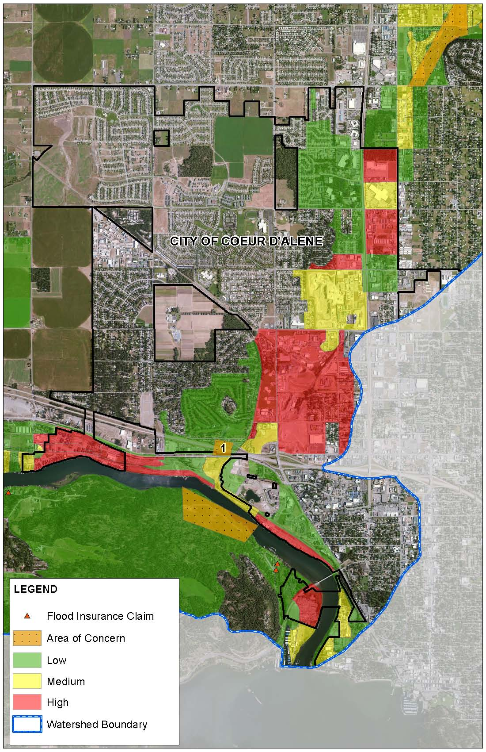

Source: Kootenai County

## 3.3 City of Dalton Gardens (CID 160164)

**Overview**

The City of Dalton Gardens is the smallest community in the Upper Spokane Watershed located within Kootenai County, which participated in the Discovery Process. The information below provides an overview of the community’s floodplain management program information as of the date of this publication.

* Participating in National Flood Insurance Program (NFIP)
* Not Participating in NFIP Community Rating System (CRS)
* Included in the Hazards Mitigation Plan for Kootenai County
* NFIP Policy Coverage (policies/value) = 1 policies totaling approximately $350,000
* NFIP-recognized repetitive loss properties = 0
* NFIP-recognized Severe Repetitive Loss properties = 0

**Hazus Estimated Loss Information**

Dalton Garden’s flood risk analysis uses results from a FEMA performed Hazus analysis which accounts for modeled areas in the study area*.* The analysis is based on multi-frequency Flood Depth grids (10%, 2%, 1%, and 0.2%)

|  |  |  |  |  |  |  |  |  |  |  |
| --- | --- | --- | --- | --- | --- | --- | --- | --- | --- | --- |
| **Estimated Potential Losses for Flood Event Scenarios For City of Dalton Gardens** | | | | | | | | | | |
|  | **Total Inventory** | | **10% (10-yr)** | | **2% (50-yr)** | | **1% (100-yr)** | | **0.2% (500-yr)** | |
|  | **Estimated Value** | **% of Total** | **Dollar Losses1** | **Loss Ratio2** | **Dollar Losses1** | **Loss Ratio2** | **Dollar Losses1** | **Loss Ratio2** | **Dollar Losses1** | **Loss Ratio2** |
| **Residential Buildings/Contents** | $98,400,000 | 42% | $450,000 | 0% | $730,000 | 1% | $960,000 | 1% | $1,350,000 | 1% |
| **Commercial Buildings/Contents** | $108,810,000 | 46% | $910,000 | 1% | $1,140,000 | 1% | $1,420,000 | 1% | $1,670,000 | 2% |
| **Other Building/Contents** | $29,550,000 | 12% | $420,000 | 1% | $530,000 | 2% | $650,000 | 2% | $760,000 | 3% |
| **Total Building/Contents3** | **$236,760,000** | **100%** | **$1,770,000** | **1%** | **$2,390,000** | **1%** | **$3,030,000** | **1%** | **$3,780,000** | **2%** |
| **Business Disruption4** | N/A | N/A | $330,000 | N/A | $400,000 | N/A | $480,000 | N/A | $560,000 | N/A |
| **TOTAL5** | **$236,760,000** | **N/A** | **$2,100,000** | **N/A** | **$2,790,000** | **N/A** | **$3,510,000** | **N/A** | **$4,340,000** | **N/A** |

Source:  Hazus analysis results stored as the Flood Risk Assessment Dataset in the Flood Risk Database.   
1Losses shown are rounded to the nearest $10,000  
2Loss ratio = Dollar Losses ÷ Estimated Value. Loss Ratios are rounded to the nearest integer percent.   
3Total Building/Contents Loss = Residential Building/Contents Loss + Commercial Building/Contents Loss + Other Building/Contents Loss.   
4Business Disruption = Inventory Loss + Relocation Cost + Income Loss + Rental Income Loss + Wage Loss + Direct Output Loss.   
5Total Loss = Total Building/Contents + Business Disruption

|  |  |  |  |  |
| --- | --- | --- | --- | --- |
| **Population, Debris, and Essential Facility Impacts** | | | | |
|  | **10% (10-yr)** | **2% (50-yr)** | **1% (100-yr)** | **0.2% (500-yr)** |
| **Shelter Needs** | 9 | 11 | 12 | 16 |
| **Displaced Population** | 48 | 55 | 56 | 68 |
| **Debris (in tons)** | 895 | 1,131 | 1,209 | 1,796 |
| **Fire Stations** | 0 | 0 | 0 | 0 |
| **Police Stations** | 0 | 0 | 0 | 0 |
| **Schools** | 0 | 0 | 0 | 0 |

**Areas of Concern (AOC)**

Section 6 of the Risk Report provides more information regarding areas of concern, how they are defined for this analysis, and potential mitigation actions that could be considered for each type.

|  |  |  |
| --- | --- | --- |
| **Mitigation Interest** | **Problem Statement** | **Map ID#** |
| Wildfire | Canfield Mountain is a wildfire risk. One resident lives on the mountain. (Spatial extents verification needed for mapping.) | N/A |

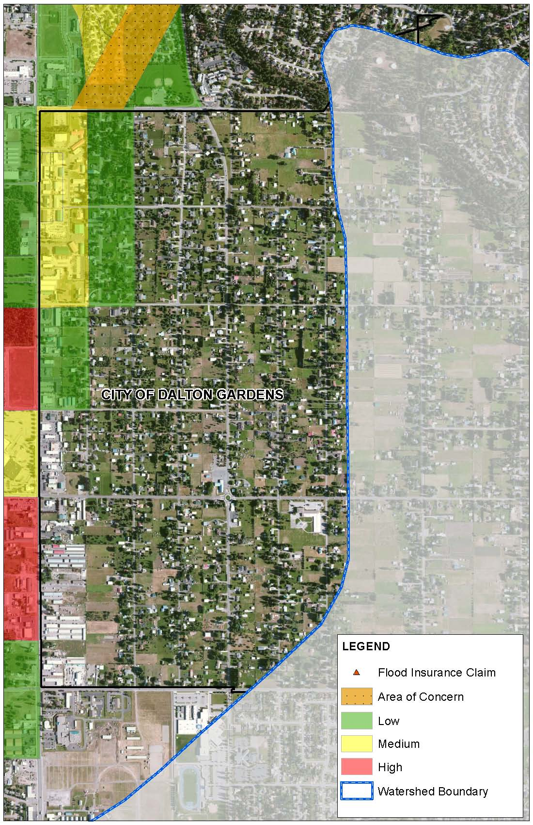

*This map summarizes the AOC identified through the discovery process*

Source: Kootenai County

## 3.4 City of Hayden Summary (CID 160170)

**Overview**

City of Hayden is one of five communities, located within Kootenai County that participated in the Upper Spokane Watershed Discovery Process for Risk MAP. The information below provides an overview of the community’s floodplain management program information as of the date of this publication.

* Participating in National Flood Insurance Program (NFIP)
* Not Participating in NFIP Community Rating System (CRS)
* Included in the Hazards Mitigation Plan for Kootenai County
* NFIP Policy Coverage (policies/value) = 4 policies totaling approximately $1,008,000
* NFIP-recognized repetitive loss properties = 0
* NFIP-recognized Severe Repetitive Loss properties = 0

**Hazus Estimated Loss Information**

Hayden’s flood risk analysis uses results from a FEMA performed Hazus analysis which accounts for modeled areas in the study area*.* The analysis is based on multi-frequency Flood Depth grids (10%, 2%, 1%, and 0.2%)

|  |  |  |  |  |  |  |  |  |  |  |
| --- | --- | --- | --- | --- | --- | --- | --- | --- | --- | --- |
| **Estimated Potential Losses for Flood Event Scenarios For City of Hayden** | | | | | | | | | | |
|  | **Total Inventory** | | **10% (10-yr)** | | **2% (50-yr)** | | **1% (100-yr)** | | **0.2% (500-yr)** | |
|  | **Estimated Value** | **% of Total** | **Dollar Losses1** | **Loss Ratio2** | **Dollar Losses1** | **Loss Ratio2** | **Dollar Losses1** | **Loss Ratio2** | **Dollar Losses1** | **Loss Ratio2** |
| **Residential Buildings/Contents** | $843,510,000 | 52% | $5,290,000 | 1% | $6,900,000 | 1% | $7,570,000 | 1% | $9,990,000 | 1% |
| **Commercial Buildings/Contents** | $645,470,000 | 40% | $3,320,000 | 1% | $4,590,000 | 1% | $4,890,000 | 1% | $5,870,000 | 1% |
| **Other Building/Contents** | $125,770,000 | 8% | $460,000 | 0% | $810,000 | 1% | $880,000 | 1% | $1,110,000 | 1% |
| **Total Building/Contents3** | **$1,614,760,000** | **100%** | **$9,070,000** | **1%** | **$12,290,000** | **1%** | **$13,330,000** | **1%** | **$16,970,000** | **1%** |
| **Business Disruption4** | N/A | N/A | $440,000 | N/A | $640,000 | N/A | $690,000 | N/A | $820,000 | N/A |
| **TOTAL5** | **$1,614,760,000** | **N/A** | **$9,510,000** | **N/A** | **$12,930,000** | **N/A** | **$14,020,000** | **N/A** | **$17,790,000** | **N/A** |

Source:  Hazus analysis results stored as the Flood Risk Assessment Dataset in the Flood Risk Database.   
1Losses shown are rounded to the nearest $10,000  
2Loss ratio = Dollar Losses ÷ Estimated Value. Loss Ratios are rounded to the nearest integer percent.   
3Total Building/Contents Loss = Residential Building/Contents Loss + Commercial Building/Contents Loss + Other Building/Contents Loss.   
4Business Disruption = Inventory Loss + Relocation Cost + Income Loss + Rental Income Loss + Wage Loss + Direct Output Loss.   
5Total Loss = Total Building/Contents + Business Disruption

|  |  |  |  |  |
| --- | --- | --- | --- | --- |
| **Population, Debris, and Essential Facility Impacts** | | | | |
|  | **10% (10-yr)** | **2% (50-yr)** | **1% (100-yr)** | **0.2% (500-yr)** |
| **Shelter Needs** | 488 | 610 | 666 | 772 |
| **Displaced Population** | 699 | 841 | 903 | 1,013 |
| **Debris (in tons)** | 6,065 | 7,329 | 8,276 | 12,543 |
| **Fire Stations** | 0 | 0 | 0 | 0 |
| **Police Stations** | 0 | 0 | 0 | 0 |
| **Schools** | 0 | 0 | 1 | 1 |

**Areas of Concern (AOC)**

Section 6 of this report provides more information regarding areas of concern, how they are defined for this analysis, and potential mitigation actions that could be considered for each type.

|  |  |  |
| --- | --- | --- |
| **Mitigation Interest** | **Problem Statement** | **Map ID #** |
| Flood | Earthen dams are located along the lake at the city boundary. (Spatial extents verification needed for mapping.) |  |
| Flood | There is a flood potential from ponding caused by drainage issues in this area. | 2, 3 |
| Landslide | Hayden Canyon area in the northeast section of Hayden has significant slopes and is a concern for landslides. | 4 |
| Flood | All sanitary sewers are pumped out of the City of Hayden. Sand bagging efforts around lift stations have been required for protection of these facilities from flooding. | 5, 6 |

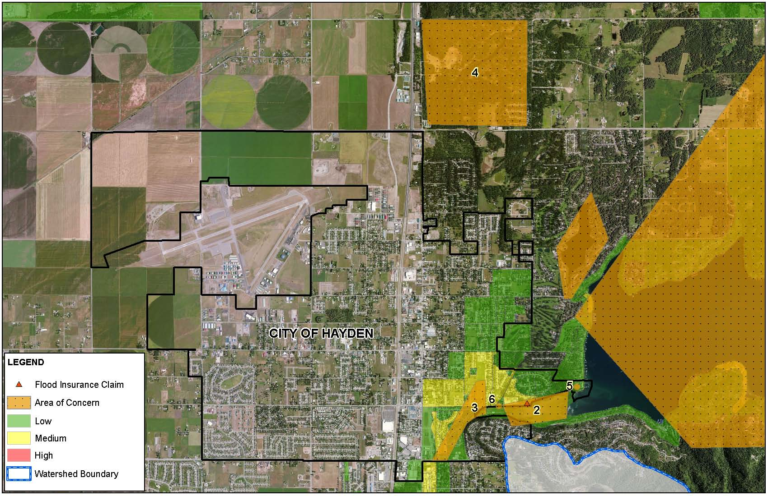

*This map summarizes the AOC identified through the discovery process*

Source: Kootenai County

## 3.5 City of Post Falls (CID 160083)

**Overview**

The information below provides an overview of the community’s floodplain management program information as of the date of this publication.

* Participating in National Flood Insurance Program (NFIP)
* Not participating in NFIP Community Rating System (CRS)
* Included in the All-Hazards Mitigation Plan for Kootenai County
* NFIP Policy Coverage (policies/value) = 12 policies totaling approximately $2,846,000
* NFIP-recognized repetitive loss properties = 0
* NFIP-recognized Severe Repetitive Loss properties = 0

**Hazus Estimated Loss Information**

Post Falls’ flood risk analysis uses results from a FEMA performed Hazus analysis which accounts for modeled areas in the study area*.* The analysis is based on multi-frequency Flood Depth grids (10%, 2%, 1% and 0.2 %.)

|  |  |  |  |  |  |  |  |  |  |  |
| --- | --- | --- | --- | --- | --- | --- | --- | --- | --- | --- |
| **Estimated Potential Losses for Flood Event Scenarios For City of Post Falls** | | | | | | | | | | |
|  | **Total Inventory** | | **10% (10-yr)** | | **2% (50-yr)** | | **1% (100-yr)** | | **0.2% (500-yr)** | |
|  | **Estimated Value** | **% of Total** | **Dollar Losses1** | **Loss Ratio2** | **Dollar Losses1** | **Loss Ratio2** | **Dollar Losses1** | **Loss Ratio2** | **Dollar Losses1** | **Loss Ratio2** |
| **Residential Buildings/Contents** | $1,401,390,000 | 55% | $7,580,000 | 1% | $9,470,000 | 1% | $9,750,000 | 1% | $10,550,000 | 1% |
| **Commercial Buildings/Contents** | $876,110,000 | 35% | $7,720,000 | 1% | $10,530,000 | 1% | $12,050,000 | 1% | $15,930,000 | 2% |
| **Other Building/Contents** | $260,080,000 | 10% | $930,000 | 0% | $1,730,000 | 1% | $1,950,000 | 1% | $2,650,000 | 1% |
| **Total Building/Contents3** | **$2,537,580,000** | **100%** | **$16,230,000** | **1%** | **$21,730,000** | **1%** | **$23,760,000** | **1%** | **$29,130,000** | **1%** |
| **Business Disruption4** | N/A | N/A | $970,000 | N/A | $1,350,000 | N/A | $1,500,000 | N/A | $1,920,000 | N/A |
| **TOTAL5** | **$2,537,580,000** | **N/A** | **$17,200,000** | **N/A** | **$23,080,000** | **N/A** | **$25,260,000** | **N/A** | **$31,050,000** | **N/A** |

Source:  Hazus analysis results stored as the Flood Risk Assessment Dataset in the Flood Risk Database.   
1Losses shown are rounded to the nearest $10,000  
2Loss ratio = Dollar Losses ÷ Estimated Value. Loss Ratios are rounded to the nearest integer percent.   
3Total Building/Contents Loss = Residential Building/Contents Loss + Commercial Building/Contents Loss + Other Building/Contents Loss.   
4Business Disruption = Inventory Loss + Relocation Cost + Income Loss + Rental Income Loss + Wage Loss + Direct Output Loss.   
5Total Loss = Total Building/Contents + Business Disruption

|  |  |  |  |  |
| --- | --- | --- | --- | --- |
| **Population, Debris, and Essential Facility Impacts** | | | | |
|  | **10% (10-yr)** | **2% (50-yr)** | **1% (100-yr)** | **0.2% (500-yr)** |
| **Shelter Needs** | 557 | 672 | 725 | 840 |
| **Displaced Population** | 801 | 915 | 969 | 1,077 |
| **Debris (in tons)** | 13,434 | 16,750 | 18,707 | 22,780 |
| **Fire Stations** | 0 | 0 | 0 | 0 |
| **Police Stations** | 0 | 0 | 0 | 0 |
| **Schools** | 0 | 0 | 0 | 0 |

**Areas of Concern (AOC)**

Section 6 of the Risk Report provides more information regarding areas of concern and possible mitigation interests, how they are defined for this analysis, and potential mitigation actions that could be considered for each type.

|  |  |  |
| --- | --- | --- |
| **Mitigation Interest** | **Problem Statement** | **Map ID #** |
| Environmentally Sensitive Area | Q’emiln Park | 8 |
| Fire | Moderate to high fire risks exist in open field areas and north of HWY 53 and south of Spokane River. Local officials are interested in outreach and education for home owners on fire prevention and defensible space. (Spatial extents verification needed for mapping.) |  |

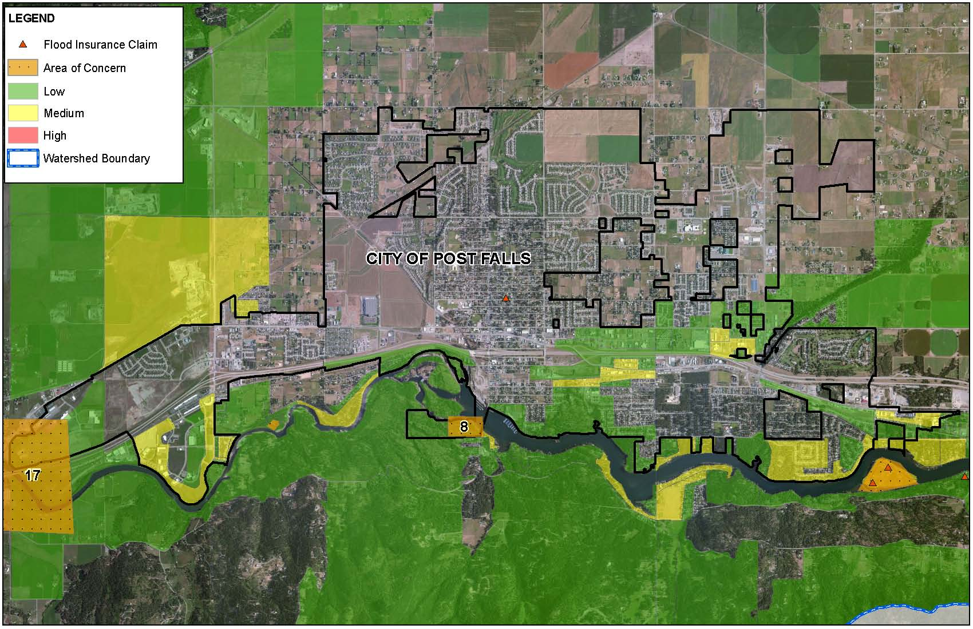

*This map summarizes the AOC identified through the discovery process*

Source: Kootenai County

## 3.6 City of Rathdrum (CID 160083)

**Overview**

The information below provides an overview of the community’s floodplain management program information as of the date of this publication.

* Participating in National Flood Insurance Program (NFIP)
* Not participating in NFIP Community Rating System (CRS)
* Included in the All-Hazards Mitigation Plan for Kootenai County
* NFIP Policy Coverage (policies/value) = 21 policies totaling approximately $3,102,300
* NFIP-recognized repetitive loss properties = 0
* NFIP-recognized Severe Repetitive Loss properties = 0

**Hazus Estimated Loss Information**

Rathdrum’s flood risk analysis uses results from a FEMA performed Hazus analysis which accounts for modeled areas in the study area*.* The analysis is based on multi-frequency Flood Depth grids (10%, 2%, 1%, and 0.2 %.)

|  |  |  |  |  |  |  |  |  |  |  |
| --- | --- | --- | --- | --- | --- | --- | --- | --- | --- | --- |
| **Estimated Potential Losses for Flood Event Scenarios For City of Rathdrum** | | | | | | | | | | |
|  | **Total Inventory** | | **10% (10-yr)** | | **2% (50-yr)** | | **1% (100-yr)** | | **0.2% (500-yr)** | |
|  | **Estimated Value** | **% of Total** | **Dollar Losses1** | **Loss Ratio2** | **Dollar Losses1** | **Loss Ratio2** | **Dollar Losses1** | **Loss Ratio2** | **Dollar Losses1** | **Loss Ratio2** |
| **Residential Buildings/Contents** | $327,380,000 | 78% | $10,070,000 | 3% | $16,420,000 | 5% | $17,940,000 | 5% | $24,050,000 | 7% |
| **Commercial Buildings/Contents** | $36,530,000 | 9% | $1,380,000 | 4% | $1,730,000 | 5% | $1,970,000 | 5% | $2,890,000 | 8% |
| **Other Building/Contents** | $57,110,000 | 14% | $6,980,000 | 12% | $7,240,000 | 13% | $7,310,000 | 13% | $11,030,000 | 19% |
| **Total Building/Contents3** | **$421,020,000** | **100%** | **$18,430,000** | **4%** | **$25,390,000** | **6%** | **$27,220,000** | **6%** | **$37,970,000** | **9%** |
| **Business Disruption4** | N/A | N/A | $1,070,000 | N/A | $1,140,000 | N/A | $1,160,000 | N/A | $1,660,000 | N/A |
| **TOTAL5** | **$421,020,000** | **N/A** | **$19,500,000** | **N/A** | **$26,530,000** | **N/A** | **$28,380,000** | **N/A** | **$39,630,000** | **N/A** |

Source:  Hazus analysis results stored as the Flood Risk Assessment Dataset in the Flood Risk Database.   
1Losses shown are rounded to the nearest $10,000  
2Loss ratio = Dollar Losses ÷ Estimated Value. Loss Ratios are rounded to the nearest integer percent.   
3Total Building/Contents Loss = Residential Building/Contents Loss + Commercial Building/Contents Loss + Other Building/Contents Loss.   
4Business Disruption = Inventory Loss + Relocation Cost + Income Loss + Rental Income Loss + Wage Loss + Direct Output Loss.   
5Total Loss = Total Building/Contents + Business Disruption

|  |  |  |  |  |
| --- | --- | --- | --- | --- |
| **Population, Debris, and Essential Facility Impacts** | | | | |
|  | **10% (10-yr)** | **2% (50-yr)** | **1% (100-yr)** | **0.2% (500-yr)** |
| **Shelter Needs** | 916 | 1,125 | 1,182 | 1,338 |
| **Displaced Population** | 1,192 | 1,411 | 1,508 | 1,674 |
| **Debris (in tons)** | 1,628 | 2,497 | 3,008 | 3,791 |
| **Fire Stations** | 0 | 0 | 0 | 0 |
| **Police Stations** | 1 | 1 | 1 | 1 |
| **Schools** | 0 | 0 | 0 | 0 |

**Areas of Concern (AOC)**

Section 6 of the Risk Report provides more information regarding areas of concern and possible mitigation interests, how they are defined for this analysis, and potential mitigation actions that could be considered for each type.

|  |  |  |
| --- | --- | --- |
| **Mitigation Interest** | **Problem Statement** | **Map ID #** |
| Flood | The Willow Creek dike is critical for groundwater recharge. (Spatial extents verification needed for mapping.) |  |
| Flood | The Bingham Street culvert size is inadequate according to local officials. | 9 |
| Flood | There is major development occurring in the southern portion of the city. This may be an area that should be mapped in more detail for flooding. (Spatial extents verification needed for mapping.) |  |
| Severe Storms | High winds causing drifting snow are a concern to community leaders. Additional snow volume management planning may be of interest. | N/A |

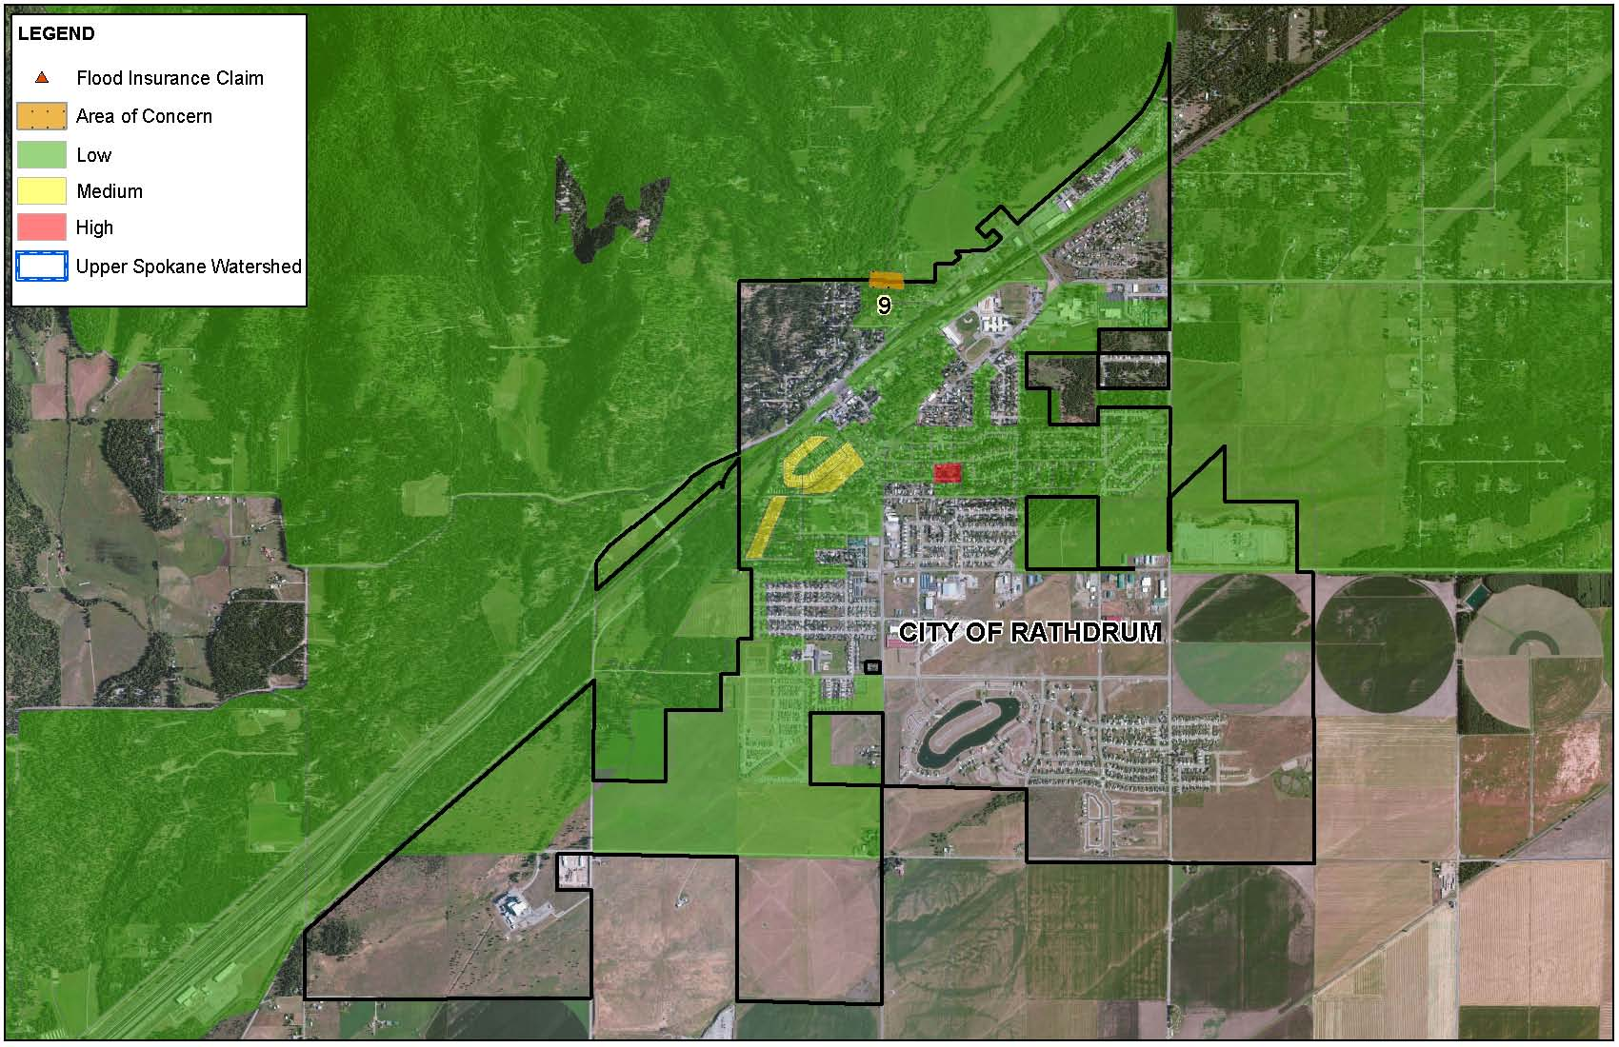

*This map summarizes the AOC identified through the discovery process*

Source: Kootenai County

## 3.7 Kootenai County Incorporated and Unincorporated Areas (CID 160076)

**Overview**

The information below provides an overview of the community’s floodplain management program information as of the date of this publication.

* Participating in National Flood Insurance Program (NFIP)
* Participating in NFIP Community Rating System (CRS)
* Included in the All-Hazards Mitigation Plan for Kootenai County
* NFIP Policy Coverage (policies/value) = 284 policies totaling approximately $63,005,900
* NFIP-recognized repetitive loss properties = 8

**Hazus Estimated Loss Information**

Kootenai’s flood risk analysis uses results from a FEMA performed Hazus analysis which accounts for modeled areas in the study area*.* The analysis is based on multi-frequency Flood Depth grids (10%, 2%, 1%, and 0.2 %.)

|  |  |  |  |  |  |  |  |  |  |  |
| --- | --- | --- | --- | --- | --- | --- | --- | --- | --- | --- |
| **Estimated Potential Losses for Flood Event Scenarios For Kootenai County** | | | | | | | | | | |
|  | **Total Inventory** | | **10% (10-yr)** | | **2% (50-yr)** | | **1% (100-yr)** | | **0.2% (500-yr)** | |
|  | **Estimated Value** | **% of Total** | **Dollar Losses1** | **Loss Ratio2** | **Dollar Losses1** | **Loss Ratio2** | **Dollar Losses1** | **Loss Ratio2** | **Dollar Losses1** | **Loss Ratio2** |
| **Residential Buildings/Contents** | $2,329,850,000 | 74% | $101,870,000 | 4% | $129,900,000 | 6% | $143,230,000 | 6% | $161,550,000 | 7% |
| **Commercial Buildings/Contents** | $563,560,000 | 18% | $36,580,000 | 6% | $47,730,000 | 8% | $51,170,000 | 9% | $59,290,000 | 11% |
| **Other Building/Contents** | $249,770,000 | 8% | $9,870,000 | 4% | $13,140,000 | 5% | $14,180,000 | 6% | $17,080,000 | 7% |
| **Total Building/Contents3** | **$3,143,180,000** | **100%** | **$148,320,000** | **5%** | **$190,770,000** | **6%** | **$208,590,000** | **7%** | **$237,930,000** | **8%** |
| **Business Disruption4** | N/A | N/A | $7,160,000 | N/A | $9,040,000 | N/A | $9,710,000 | N/A | $11,150,000 | N/A |
| **TOTAL5** | **$3,143,180,000** | **N/A** | **$155,480,000** | **N/A** | **$199,810,000** | **N/A** | **$218,300,000** | **N/A** | **$249,080,000** | **N/A** |

Source:  Hazus analysis results stored as the Flood Risk Assessment Dataset in the Flood Risk Database.   
1Losses shown are rounded to the nearest $10,000  
2Loss ratio = Dollar Losses ÷ Estimated Value. Loss Ratios are rounded to the nearest integer percent.   
3Total Building/Contents Loss = Residential Building/Contents Loss + Commercial Building/Contents Loss + Other Building/Contents Loss.   
4Business Disruption = Inventory Loss + Relocation Cost + Income Loss + Rental Income Loss + Wage Loss + Direct Output Loss.   
5Total Loss = Total Building/Contents + Business Disruption

|  |  |  |  |  |
| --- | --- | --- | --- | --- |
| **Population, Debris, and Essential Facility Impacts** | | | | |
|  | **10% (10-yr)** | **2% (50-yr)** | **1% (100-yr)** | **0.2% (500-yr)** |
| **Shelter Needs** | 1,618 | 1,964 | 2,098 | 2,469 |
| **Displaced Population** | 2,572 | 2,949 | 3,086 | 3,540 |
| **Debris (in tons)** | 33,903 | 43,126 | 47,515 | 60,134 |
| **Fire Stations** | 0 | 0 | 0 | 0 |
| **Police Stations** | 0 | 0 | 0 | 0 |
| **Schools** | 0 | 1 | 1 | 1 |

**Areas of Concern (AOC)**

Section 6 of the Risk Report provides more information regarding areas of concern and possible mitigation interests, how they are defined for this analysis, and potential mitigation actions that could be considered for each type.

|  |  |  |
| --- | --- | --- |
| **Mitigation Interest** | **Problem Statement** | **Map ID #** |
| Wildfire | Wildfire evacuation routes are of concern within the county. | N/A |
| Environmentally Sensitive Area | Corbin Park | 10 |
| Landslide | There is a potential for landslide risk in this area. | 11 |
| Flood | Several LOMAs exist around Hayden Lake. A redelineation of the lake is needed if more detailed topography exists. | 12 |
| Flood | There is a nuisance flooding area in the City of Hauser in a farming region. This is an area of repeated flooding but no claims have been submitted since they are not part of the NFIP. | 13 |
| Flood | A Flood Insurance Study update to incorporate BFEs is requested here. | 14 |
| Flood | Harbor Island Seawall may protect the island more than the effective floodplain shows. | 15 |
| Flood | Base Flood Elevations (BFE) for the Spokane River do not match up across the state line. | 17 |
| Flood | Hazel’s Creek 500-year floodplain revision is requested in this area. (Spatial extents verification needed for mapping.) |  |
| Severe Storms | Formal plan for shelter operations is of interest to community leaders. | N/A |
| Severe Storms | Resources are exhausted (man power, financial, materials) during widespread disasters. There are no backups or relief plan currently in place. | N/A |
| Severe Storms | Snow volume management planning is requested by community leaders. | N/A |
| Severe Storms | Transportation needs and communications enhancement assistance during hazard events are of interest to community leaders. | N/A |

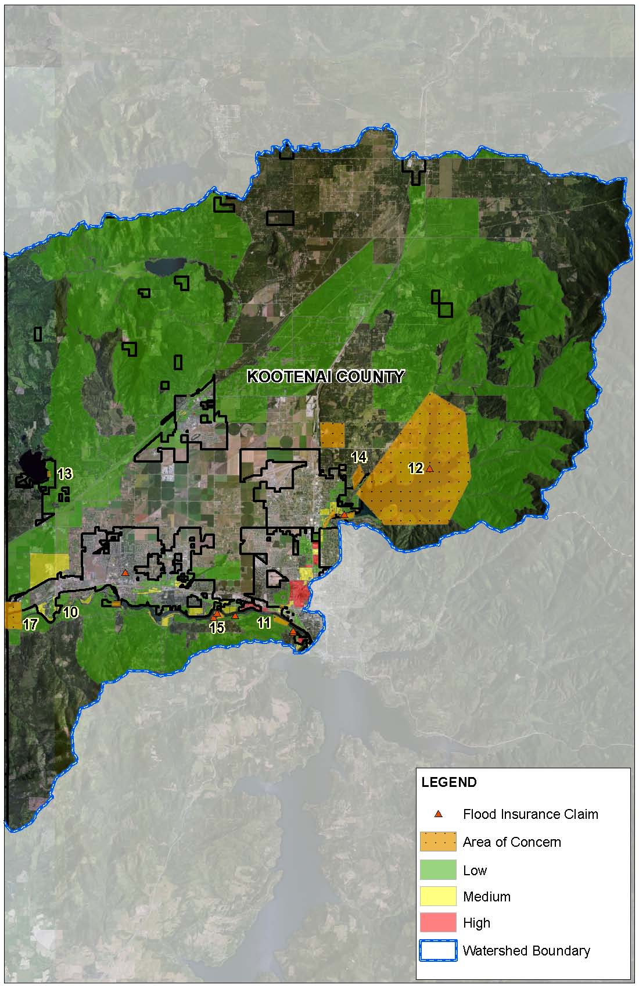

*This map summarizes the AOC identified through the discovery process*

Source: Kootenai County

# 4. Earthquake Risk Analysis Results

The following pages provide general risk assessment results of the analyses at the county level.

**Upper Spokane Watershed Earthquake Summary**

## 4.1 United States Geologic Survey (USGS) Scenario ShakeMap

Currently, there is no USGS ShakeMap for Kootenai County. Below is the closest USGS ShakeMap to the county and is a scenario event for a 5.5M earthquake centered on the City of Spokane. Areas of orange are the highest intensity shaking. This ShakeMap was created by the USGS in 2009.

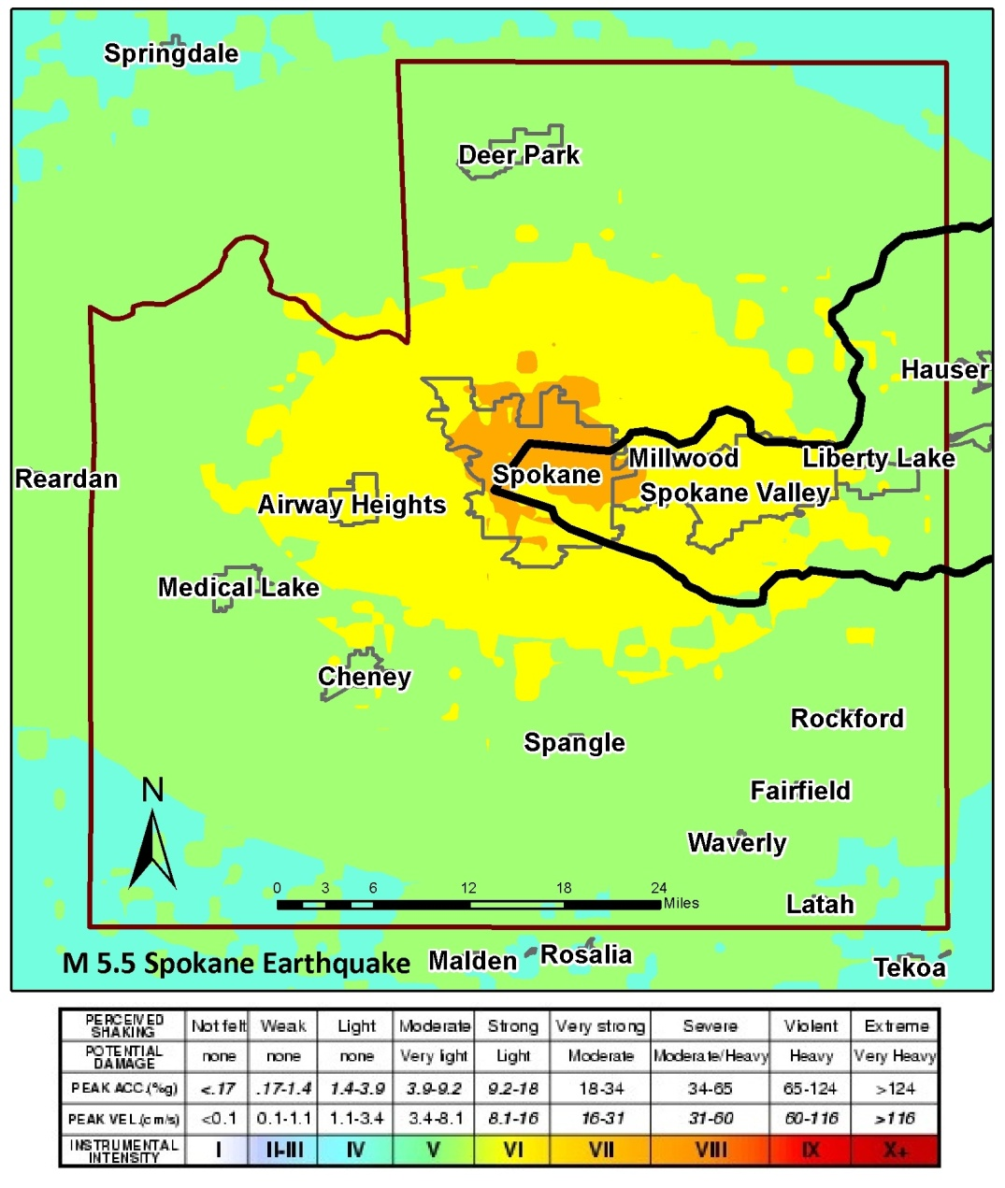

Effects to Kootenai County based on Hazus runs with this scenario displayed minimal to no damages. A more detailed Hazus run with updated data from the county may yield more damages and thus provide a more accurate planning tool. Updates can be conducted for soil data, liquefaction, general building stock, building type (wood frame, unreinforced masonry, etc.), and parcel information.



Seismic Profile of fault in Spokane being studied by USGS

Additional updates in Hazus can include new Shakemaps provided by the USGS. Currently, the USGS is conducting a study on a newly found fault north of Downtown Spokane. Once this fault is studied and understood, a new Shakemap may be generated. The USGS is currently installing new seismometers in the area and will soon begin trenching for fault analysis.

It is important to note that the limited seismic data available for Kootenai County does not mean the area is free of risk. The image below shows measured seismicity in Idaho greater than a M3.0 from 1872-2000. The presence of earthquakes demonstrates that seismicity is a risk throughout the State and appropriate planning and preparedness actions should be taken.

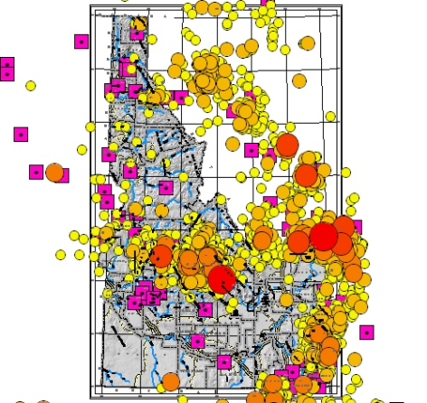

1872-2000 Instrumental Seismicity M> 3.0

# Wildfire Risk Overview

## 5.1 Wildfire Overview

A Wildland-Urban Interface (WUI) fire is a wildfire in a geographical area where structures and other human development meet or intermingle with wildland or vegetative fuels. Kootenai County communities have an abundance of WUI areas identified where fuel reduction projects are identified.

The three factors that greatly affect how a wildfire will burn include fuel, topography, and weather. The type and amount of **fuel**, as well as its burning qualities and level of moisture affect wildfire potential and behavior. The continuity of fuels, expressed in both horizontal and vertical components is also a factor. **Topography** affects the movement of air (and thus the fire) over the ground surface. The slope and shape of terrain can change the rate of speed at which the fire travels. **Weather** affects the probability of wildfire and has a significant effect on its behavior. Temperature, humidity, and wind (both short and long term) affect the severity and duration of wildfires.

## Fire Regime Condition Class (FRCC)

Describing the fire regime and condition class of the fuels in the planning area will provide historical reference and a basic understanding of the wildfire risk to the community.

A fire regime can be described in cycles because some parts of the histories usually get repeated, and the repetitions can be counted and measured, such as fire return interval. You can access fire effects/fire ecology data to learn more about fire regime characterizations and summaries on plant, animal, and vegetation communities for your specific area by exploring the Fire Effects Information System (FEIS; [www.fs.fed.us/database/feis/](http://www.fs.fed.us/database/feis/)).

*Table 5.1. The Five Historic Natural Fire Regime Groups*

|  |  |  |
| --- | --- | --- |
| **Fire Regime Group** | **Frequency (Fire Return Interval)** | **Severity** |
| I | 0-35 years | Low severity |
| II | 0-35 years | Stand Replacement Severity |
| III | 35-100+ years | Mixed Severity |
| IV | 35-100+ years | Stand Replacement Severity |
| V | >200 years | Stand Replacement Severity |

Fire regime condition class (FRCC) is a standardized tool for determining the degree to which current vegetation and fire regime conditions have departed from historical reference conditions.

Three “condition classes” have been developed to categorize the current condition with respect to each of the five historic Fire Regime Groups.

*Table 5.2. Fire Regime Condition Class Classifications*

|  |  |  |
| --- | --- | --- |
| **Fire Regime** | **Condition Class**  **Description** | **Potential Risks** |
| Condition Class I | Within the natural (historical) range of variability of vegetation  characteristics; fuel  composition; fire frequency, severity and pattern; and other  associated disturbances | * Fire behavior, effects, and other associated disturbances are similar to those that occurred prior to fire exclusion (suppression) and other types of management that do not mimic the natural fire regime and associated vegetation and fuel characteristics. * Composition and structure of vegetation and fuels are similar to the natural (historical) regime. * Risk of loss of key ecosystem components (e.g. native species, large trees, and soil) are low |
| Condition Class II | Moderate departure from the natural (historical) regime of vegetation characteristics; fuel  composition; fire frequency, severity and pattern; and other  associated disturbances | * Fire behavior, effects, and other associated disturbances are moderately departed (more or less severe). * Composition and structure of vegetation and fuel are moderately altered. * Uncharacteristic conditions range from low to moderate; * Risk of loss of key ecosystem components are moderate. |
| Condition Class III | High departure from the  natural (historical) regime of vegetation characteristics; fuel  composition; fire frequency,  severity and pattern; and other associated disturbances | * Fire behavior, effects, and other associated disturbances are highly departed (more or less severe). * Composition and structure of vegetation and fuel are highly altered. * Uncharacteristic conditions range from moderate to high. * Risk of loss of key ecosystem components are high |

Source: http://www.nwcg.gov/teams/wfewt/archive/message/FrccDefinitions.pdf

A complete definition, background information, and the nationally consistent methodology for calculating and mapping fire regime condition class are available at [www.frcc.gov](http://www.frcc.gov). (NWCG)

Currently, the communities in Kootenai County can access and use the Fire Regime Condition Class datasets on Landfire (<http://www.landfire.gov>) to understand their wildfire risk. As Figure 5.1 demonstrates, generally the FRCC in the watershed is Class II. The areas of concern are those Class III located in the Wildland-Urban Interface areas. These may be areas with a great wildfire risk.

Keep in mind that FRCC data is limited because it is solely focused on the current natural conditions and doesn’t consider local response capabilities, mitigation efforts, and other inputs that can affect the wildfire risk to a community. Enhancing this data set with local data will improve its effectiveness to understand wildfire risk.

*Figure 5.1. Fire Regime Condition Class (FRCC) for Upper Spokane Watershed (Kootenai County)*

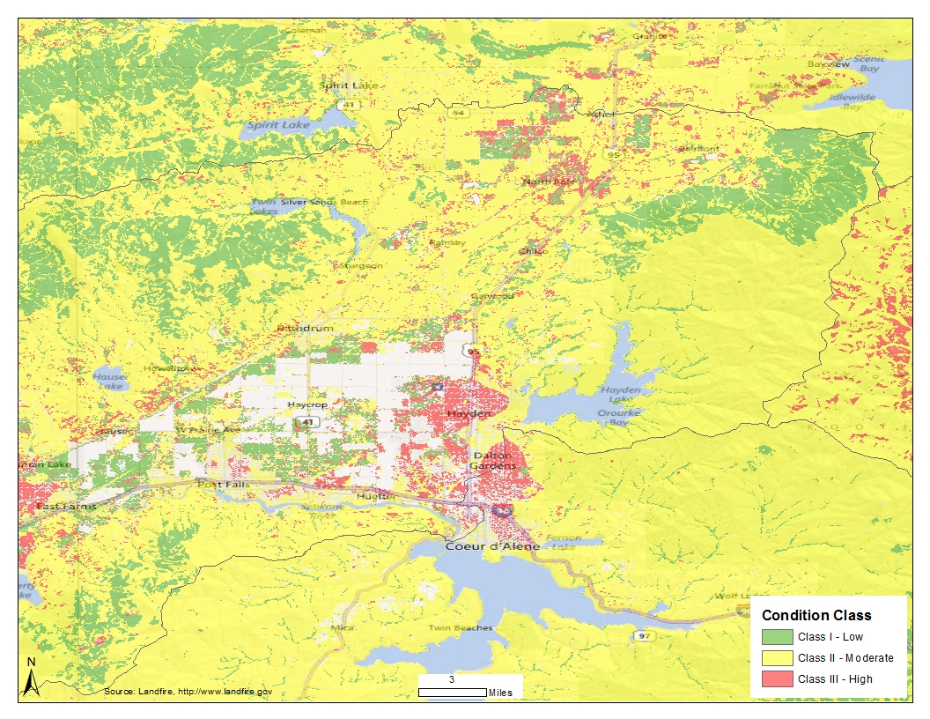

Source: Landfire. <http://www.landfire.gov>

## Data Gap

To asses and designate areas with wildfire risk, the *Kootenai County Community Wildfire Protection Plan* (CWPP) was developed. The document is the result of analyses, professional cooperation and collaboration, assessments of wildfire risks and other factors by the Kootenai County Wildland Urban Interface Fire Mitigation Planning Committee, a subcommittee of the Local Emergency Planning Committee. The intent of this document is to reduce the potential for wildfires that threaten people, structures, infrastructure, and the natural ecosystems in Kootenai County. The projects are re-evaluated each year and updated in the plan.

The *Kootenai County Multi-Jurisdictional All Hazard Mitigation Plan* (2009) identifies a variety of natural hazards and offers strategies to mitigate the risk to the hazards. The wildfire profile of the plan incorporates information from the Community Wildfire Protection Plan.

An important action item identified in the All Hazard Mitigation Plan, and validated through interviews with community officials in May and September 2012, is the lack of wildfire risk data to help better prioritize fuel treatment areas. There is no identified wildfire risk database that the County and Cities use.

A project that will provide an up-to-date wildfire risk assessment and accompanying database to address any data limitations that the community may have is the West Wide Wildfire Risk Assessment.

## West Wide Wildfire Risk Assessment (WWA)

The West Wide Wildfire Risk Assessment is a 17 state and selected Pacific Islands effort led by the Council of Western State Foresters and the Western Forestry Leadership Coalition (WFLC). The project website ([http://www.westwideriskassessment.com](http://www.westwideriskassessment.com/)) states,

“The WWA will produce a wildfire risk assessment to quantify the magnitude of the current wildland fire problem in the west and provide a baseline for quantifying mitigation activities and monitoring change over time. It will be used to facilitate national, regional and state level strategic planning and policy discussions. The methodology implemented will provide results comparable across the entire West providing a consistent basis for interpretation and use.”

The deliverables for the project include

* **Comprehensive Wildfire Database:** A comprehensive GIS data repository reflecting current conditions will be developed. This GIS database will leverage existing federal mapping programs combined with state, tribal and local data.  The database will not only be used to derive the assessment outputs but will also be delivered to support on-going fire protection planning efforts
* **Conducting the Wildfire Risk Assessment:**  The assessment will utilize the GIS database and leverage existing proven risk models to derive measures of wildfire threat, fire effects, wildfire risk and communities-at-risk.  Since a significant part of the fire problem in the west is associated with federal and tribal lands, and many of these fires affect state jurisdiction, the assessment will include all lands.
* **Final Report – Methods, Findings and Using the Assessment Products:**  A summary of the risk assessment methods and findings will be developed including state and regional statistics.  The assessment summary reports will facilitate comprehensive comparisons between regional geographic areas and states.
* **Technology Transfer** is a key element of the WWA project and outputs will be delivered with detailed information in a form ready to use by project partners. Nonetheless, it will be the responsibility of the user to be familiar with the value, assumptions, and accuracy of WWA products.  More specific information will be developed as the assessment progresses.

Of importance to this Risk Report are the following model outputs which can be utilized to develop and prioritize projects based on wildfire risk in Kootenai County.

* **Wildland Fire Susceptibility Index** (Wildfire Threat)
* **Level of Concern Index** (Wildfire Risk)

Each state involved in the project has a designated point of contact. The Point of Contact for the State of Idaho is Andrew Mock, Department of Lands, Coeur d’Alene office. He can be contacted at (208) 666-8630 or [amock@idl.idaho.gov](mailto:amock@idl.idaho.gov).

All the communities within Kootenai County will benefit from the new data. It’s expected that the data will be released by the end of 2012. The communities will be able to incorporate their own local data to help improve/refine the risk assessment so that it is more community specific.

## References

Federal Emergency Management Agency (FEMA). August 2001. “Understanding Your Risks: Identifying Hazards and Estimating Losses (FEMA 386-2). Retrieved at: <http://www.fema.gov/library/viewRecord.do?id=1880>

National Wildfire Coordinating Group (NWCG). “Communicator's Guide for Wildland Fire Management: Fire Education, Prevention, and Mitigation Practices”. Retrieved at: <http://www.nifc.gov/prevEdu/prevEdu_communicatorGuide.html>

West Wide Wildfire Risk Assessment. [http://www.westwideriskassessment.com](http://www.westwideriskassessment.com/)

# Actions to Reduce Risk

Before Mitigation and After Mitigation

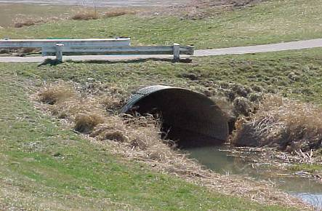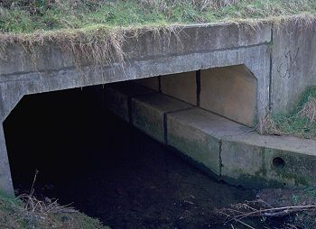

Communities will need to prioritize projects as part of the planning process. FEMA can then help route federal mitigation dollars to fund these projects.

## Types of Mitigation Actions

Mitigation provides a critical foundation on which to reduce loss of life and property by avoiding or lessening the impact of hazard events. This creates safer communities, and facilitates resiliency by enabling communities to return to normal function as quickly as possible after a hazard event. Once a community understands its risk, it is in a better position to identify potential mitigation actions that can reduce the risk to its people and property.

The mitigation plan requirements in 44 CFR Part 201 encourage communities to understand their vulnerability to hazards and take actions to minimize vulnerability and promote resilience. Mitigation actions generally fall into the following categories:

**Preventative Measures**

Preventative measures are intended to keep hazards from getting worse. They can reduce future vulnerability to flooding and/or the earthquake hazard, especially in areas where development has not yet occurred or where capital improvements have not been substantial.

The National Flood Insurance Program's (NFIP) Community Rating System (CRS) is a voluntary incentive program that recognizes and encourages community floodplain management activities that exceed the minimum NFIP requirements. As a result, flood insurance premium rates are discounted to reflect the reduced flood risk resulting from the community actions meeting the three goals of the CRS: To reduce flood losses, to facilitate accurate insurance rating; and to promote the awareness of flood insurance.

For CRS participating communities, flood insurance premium rates are discounted in increments of 5%; i.e., a Class 1 community would receive a 45% premium discount, while a Class 9 community would receive a 5% discount (a Class 10 is not participating in the CRS and receives no discount).

* Comprehensive land use planning
* Zoning regulations
* Subdivision regulations
* Open space preservation
* Building codes
* Floodplain development regulations
* Stormwater management
* Purchase development rights or conservation easements
* Participation in the NFIP Community Rating System (CRS)

**Property Protection Measures**

Property protection measures protect existing buildings by modifying the building to withstand floods and/or earthquakes, or by removing buildings from hazardous locations.

* Building relocation
* Acquisition and clearance
* Building elevation
* Barrier installation
* Building retrofit

**Natural Resource Protection Activities**

Natural resource protection activities reduce the impact of floods by preserving or restoring natural areas such as floodplains, wetlands, and dunes and their natural functions. Examples include the following:

* Wetland protection
* Habitat protection
* Erosion and sedimentation control
* Best management practices (BMPs)

Prevention of stream dumping activities (anti-litter campaigns)

* Improved forestry practices such as reforesting or selective timbering (extraction)

**Structural Mitigation Projects**

Structural mitigation refers to any physical construction to reduce or avoid possible impacts of hazards, which includes engineering measures and construction of hazard-resistant and protective structures and infrastructure. Structural protection such as upgrading dams/levees for already existing development and critical facilities may be a realistic alternative. However, citizens should be made aware of their residual risk.

* Reservoirs, retention, and detention basins
* Levees and floodwalls
* Channel modifications
* Channel maintenance
* Securing a structure’s foundation
* Strengthening building frames, cripple walls, and facades

**Public Education and Awareness Activities**

For more information regarding hazard mitigation techniques, best practices, and potential grant funding sources, visit [www.fema.gov](http://www.fema.gov) or contact your local floodplain manager, emergency manager, or State Hazard Mitigation Officer.

Public education and awareness activities advise residents, business owners, potential property buyers, and visitors about floods, hazardous areas, and mitigation techniques that they can use to reduce risk to themselves and their property.

* Readily available and readable updated maps
* Outreach projects
* Library
* Technical assistance
* Real estate disclosure
* Environmental education
* Providing risk information via the nightly news

**Emergency Services (ES) Measures**

Although not typically considered a mitigation technique, emergency service measures minimize the impact of an event on people and property. These are actions commonly taken immediately prior to, during, or in response to a hazard event.

* Hazard warning system
* Emergency response plan
* COOP and COG planning
* Critical facilities protection
* Health and safety maintenance
* Post-event recovery planning

*Table 6.1 below identifies possible mitigation actions for flooding risks*

|  |  |
| --- | --- |
| ***AOMI*** | ***Possible Actions to Reduce Flood Risk*** |
| *Dams* | *Engineering assessment*  *Dam upgrades and strengthening*  *Emergency Action Plan (EAPs)*  *Dam removal*  *Easement creation in impoundment and downstream inundation areas* |
| *Levees (accredited and non-accredited) and significant levee-like structures* | *Generally same as dams above*  *Purchase of flood insurance for at-risk structures* |
| *Coastal Structures*  *Jetties*  *Groins*  *Seawalls*  *Other structures* | *Increase coastal setbacks for construction*  *Habitat restoration programs*  *Wetland restoration and mitigation banking programs* |
| *Stream Flow Pinch Point*  *Undersized culverts or*  *bridge openings* | *Engineering Analysis*  *Replacement of structure pre- and post-disaster* |
| *Past Claims and IA/PA Hot Spots* | *Acquisition*  *Elevation*  *Relocation*  *Floodproofing* |
| *Major Land Use Changes (past 5 years or next 5 years)* | *Higher regulatory standards, Stormwater BMPs, Transfer of Development rights, compensatory storage and equal conveyance standards, etc.* |
| *Key emergency routes overtopped during frequent flooding events* | *Elevation*  *Creation of alternate routes*  *Design as low water crossing* |
| *Areas of Significant Riverine or Coastal Erosion* | *Relocation of buildings and infrastructure, regulations and planning, natural vegetation, hardening* |
| *Drainage or Stormwater Based Flood Hazard Areas, or Areas not Identified as Floodprone on the FIRM but known to be Inundated* | *Identification of all flood hazard areas* |
| *Areas of Mitigation Success* | *N/A* |

*Table 6.2 below identifies possible mitigation actions for earthquake risks*

|  |  |
| --- | --- |
| ***AoMI*** | ***Possible Actions to Reduce Earthquake Risk*** |
| *Building Assessments* | *Identify vulnerable structures within your community*  *Engineering assessment*  *Prioritizing building retrofits or seismic upgrades*  *Retrofitting of structural and non-structural components of critical facilities* |
| *Building Codes* | *Adopting current building codes that include the most current seismic code.*  *Implementing seismic code design for all new buildings* |
| *Liquefaction Mapping* | *Increase area liquefaction mapping*  *Protect natural resources that might be impacted by the built environment (i.e. pipelines, roadways, etc.)* |
| *Soil Mapping* | *Increase knowledge of local soils for better design of buildings, roads, and bridges.*  *Increase knowledge of how soils can impact areas by addressing setbacks of unstable soils and steep slopes, this will minimize the risk of the community.* |
| *Public Education & Safety* | *Education of K-12, citizens, elected officials, developers and businesses on earthquake safety and building codes.*  *Maintain an earthquake response plan to account for secondary hazards, such as fire and hazardous material spills.* |

## Identifying Specific Actions for your Community

As many mitigation actions are possible to lessen the impact of floods, how can a community decide which ones are appropriate to implement? There are many ways to identify specific actions most appropriate for a community. Some factors to consider may include the following:

Refer to FEMA Mitigation Planning How To Guide #3 (FEMA 386-3) “Developing the Mitigation Plan - identifying mitigation actions and implementation strategies” for more information on how to identify specific mitigation actions to address hazard risk in your community.

* Political – Is there political support to implement the action? Have political leaders participated in the planning process?
* Site characteristics – Does the site present unique challenges (e.g., significant slopes, erosion potential)?
* Flood characteristics – Are the flood waters affecting the site fast or slow moving? Is there debris associated with the flow? How deep is the flooding?

FEMA, in collaboration with the American Planning Association, has released the publication, “Integrating Hazard Mitigation into Local Planning.” This guide explains how hazard mitigation can be incorporated into several different types of local planning programs. For more information go to [www.planning.org](http://www.planning.org). or http://www.fema.gov/library.

* Social acceptance – Will the mitigation action be acceptable to the public? Does it cause social or cultural problems?
* Technical feasibility – Is the mitigation action technically feasible (e.g., making a building watertight to a reasonable depth)?
* Administrative feasibility – Is there administrative capability to implement the mitigation action?
* Legal – Does the mitigation action meet all applicable codes, regulations, and laws? Public officials may have a legal responsibility to act and inform citizens if a known hazard has been identified.
* Economic –– Is the mitigation action affordable? Is it eligible under grant or other funding programs? Can it be completed within existing budgets?
* Environmental – Does the mitigation action cause adverse impacts on the environment or can they be mitigated? Is it the most appropriate action among the possible alternatives?

Your local Hazard Mitigation Plan is a valuable place to identify and prioritize possible mitigation actions. The plan includes a mitigation strategy with mitigation actions that were developed through a public and open process. You can then add to or modify those actions based on what is learned during the course of the Risk MAP project and the information provided within this Risk Report.

## 6.3 Mitigation Programs and Assistance

Not all mitigation activities require funding (e.g., local policy actions such as strengthening a flood damage prevention ordinance), and those that do are not limited to outside funding sources (e.g. include in local capital improvements plan, etc.). For those mitigation actions that require assistance through funding or technical expertise, several State and Federal agencies have flood hazard mitigation grant programs and offer technical assistance. These programs may be funded at different levels over time or may be activated under special circumstances such as after a presidential disaster declaration.

**FEMA Mitigation Programs and Assistance**

FEMA awards many mitigation grants each year to States and communities to undertake mitigation projects to prevent future loss of life and property resulting from hazard impacts. The FEMA Hazard Mitigation Assistance (HMA) programs provide grants for mitigation through the programs listed in Table 6.3 below.

** Communities can link hazard mitigation plans and actions to the right FEMA grant programs to fund flood risk reduction. More information about FEMA HMA programs can be found at http://www.fema.gov/government/grant/hma/index.shtm.

*Table 6.3 FEMA Hazard Mitigation Assistance Programs*

|  |  |  |
| --- | --- | --- |
| **Mitigation Grant Program** | **Authorization** | **Purpose** |
| Hazard Mitigation Grant Program (HMGP) | Robert T. Stafford Disaster Relief and Emergency Assistance Act | Activated after a presidential disaster declaration; provides funds on a sliding scale formula based on a percentage of the total federal assistance for a disaster for long-term mitigation measures to reduce vulnerability to natural hazards |
| Flood Mitigation Assistance (FMA) | National Flood Insurance Reform Act | Reduce or eliminate claims against the NFIP |
| Pre-Disaster Mitigation (PDM) | Disaster Mitigation Act | National competitive program focuses on mitigation project and planning activities that address multiple natural hazards |
| Repetitive Flood Claims (RFC) | Bunning-Bereuter-Blumenauer Flood Insurance Reform Act | Reduce flood claims against the NFIP through flood mitigation; properties must be currently NFIP insured and have had at least one NFIP claim |
| Severe Repetitive Loss (SRL) | Bunning-Bereuter-Blumenauer Flood Insurance Reform Act | Reduce or eliminate the long-term risk of flood damage to SRL residential structures currently insured under the NFIP |

The HMGP and PDM programs offer funding for mitigation planning and project activities that address multiple natural hazard events. The FMA, RFC, and SRL programs focus funding efforts on reducing claims against the NFIP. Funding under the HMA programs is subject to availability of annual appropriations and under HMGP to the amount of FEMA disaster recovery assistance under a presidential major disaster declaration.

The Silver Jackets program, active in several states, is a partnership of the USACE, FEMA and state agencies. The Silver Jackets program provides a state-based strategy for an interagency approach to planning and implementing measures for risk reduction.

FEMA's HMA grants are awarded to eligible States, Tribes, and Territories (Applicant) that, in turn, provide subgrants to local governments and communities (subapplicant). The Applicant selects and prioritizes sub-applications developed and submitted to them by subapplicants and submits them to FEMA for consideration of funding. Prospective subapplicants should consult the office designated as their Applicant for further information regarding specific program and application requirements. Contact information for the FEMA [Regional Offices](http://www.fema.gov/about/contact/regions.shtm) and [State Hazard Mitigation Officers](http://www.fema.gov/about/contact/shmo.shtm) is available on the FEMA website.

**Additional Mitigation Programs and Assistance**

Several additional agencies including the US Army Corps of Engineers (USACE), Natural Resource Conservation Service (NRCS), US Geological Survey (USGS), and others have specialists and a lot of information hazard mitigation.

The State NFIP Coordinator and State Hazard Mitigation Officer are state level sources of information and assistance, which vary among different states.

# Appendix A: Acronyms and Definitions

**ACRONYMS**

**A**

AAL Average Annualized Loss

ALR Annualized Loss Ratio

**B**

BCA Benefit-Cost Analysis

BFE Base Flood Elevation

**C**

CFR Code of Federal Regulations

COG Continuity of Government Plan

COOP Continuity of Operations Plan

CRS Community Rating System

**D**

DHS Department of Homeland Security

DMA 2000 Disaster Mitigation Act of 2000

**E**

EOP Emergency Operations Plan

**F**

FEMA Federal Emergency Management Agency

FIRM Flood Insurance Rate Map

FIS Flood Insurance Study

FMA Flood Mitigation Assistance

FRD Flood Risk Database

FRM Flood Risk Map

FRR Flood Risk Report

FY Fiscal Year

**G**

GIS Geographic Information System

**H**

HMA Hazard Mitigation Assistance

HMGP Hazard Mitigation Grant Program

**N**

NFIA National Flood Insurance Act

NFIP National Flood Insurance Program

NRCS Natural Resource Conservation Service

**P**

PDM Pre-Disaster Mitigation

**R**

RFC Repetitive Flood Claims

Risk MAP Mapping, Assessment, and Planning

**S**

SFHA Special Flood Hazard Area

SHMO State Hazard Mitigation Officer

SRL Severe Repetitive Loss

**U**

USACE U.S. Army Corps of Engineers

USGS U.S. Geological Survey

**DEFINITIONS**

**1-percent-annual-chance flood** – The flood elevation that has a 1-percent chance of being equaled or exceeded each year. Sometimes referred to as the 100-year flood.

**0.2-percent-annual-chance flood** –The flood elevation that has a 0.2-percent chance of being equaled or exceeded each year. Sometimes referred to as the 500-year flood.

**Average Annualized Loss (AAL)** – The estimated long-term weighted average value of losses to property in any single year in a specified geographic area

**Annualized Loss Ratio (ALR)** – expresses the annualized loss as a fraction of the value of the local inventory (total value/annualized loss).

**Base Flood Elevation (BFE)** – Elevation of the 1-percent-annual-chance flood. This elevation is the basis of the insurance and floodplain management requirements of the NFIP.

**Berm –** A small levee, typically built from fill dirt.

**CFS** –Cubic feet per second, the unit by which discharges are measured (a cubic foot of water is about 7.5 gallons).

**Consequence (of flood)** – The estimated damages associated with a given flood occurrence.

**Crest** – The peak stage or elevation reached or expected to be reached by the floodwaters of a specific flood at a given location.

**Dam** – Any artificial barrier that impounds or diverts water and that: (1) is 25 feet or more in height from the natural bed of the stream or watercourse measured at the downstream toe of the barrier or from the lowest elevation of the outside limit of the barrier if it is not across a stream channel or watercourse, to the maximum water storage elevation or (2) has an impounding capacity at maximum water storage elevation of 50 acre-feet or more.

**Design flood event** – The greater of the following two flood events: (1) the base flood, affecting those areas identified as SFHAs on a community’s FIRM; or (2) the flood corresponding to the area designated as a flood hazard area on a community’s flood hazard map or otherwise legally designated.

**Earthquake** –The result of a sudden release of energy in the Earth’s crust that creates seismic waves.

**Epicenter** –is the point on the Earth’s surface that is directly above the point where the fault begins to rupture.

**Erosion** – Process by which floodwaters lower the ground surface in an area by removing upper layers of soil.

**Essential facilities** – Facilities that, if damaged, would present an immediate threat to life, public health, and safety. As categorized in HAZUS-MH, essential facilities include hospitals, emergency operations centers, police stations, fire stations and schools.

**Fault** –A fracture or discontinuity in a volume of rock, across which there has been significant displacement along the fractures as a result of earth movement. Energy release associated with rapid movement on active faults is the cause of most earthquakes.

**Flood** – A general and temporary condition of partial or complete inundation of two or more acres of normally dry land area or of two or more properties (at least one of which is your property) from: overflow of inland or tidal waters; unusual and rapid accumulation or runoff of surface waters from any source; mudflow; or collapse or subsidence of land along the shore of a lake or similar body of water as a result of erosion or undermining caused by waves or currents of water exceeding anticipated cyclical levels that result in a flood as defined above.

**Flood Insurance Rate Map (FIRM)** – An official map of a community, on which FEMA has delineated both the SFHAs and the risk premium zones applicable to the community. See also Digital Flood Insurance Rate Map.

**Flood Insurance Study (FIS)** – Contains an examination, evaluation, and determination of the flood hazards of a community, and if appropriate, the corresponding water-surface elevations.

**Flood risk** – Probability multiplied by consequence; the degree of probability that a loss or injury may occur as a result of flooding. Sometimes referred to as vulnerability.

**Floodborne debris impact** – Floodwater moving at a moderate or high velocity can carry floodborne debris that can impact buildings and damage walls and foundations.

**Floodwall** – A long, narrow concrete or masonry wall built to protect land from flooding.

**Floodway** (regulatory)– The channel of a river or other watercourse and that portion of the adjacent floodplain that must remain unobstructed to permit passage of the base flood without cumulatively increasing the water surface elevation more than a designated height (usually 1 foot).

**Floodway fringe** – This is the portion of the SFHA that is outside of the floodway.

**Flow pinch point** – A point where a human-made structure constricts the flow of a river or stream.

**Freeboard** – The height above the base flood added to a structure to reduce the potential for flooding. The increased elevation of a building above the minimum design flood level to provide additional protection for flood levels higher than the 1-percent chance flood level and to compensate for inherent inaccuracies in flood hazard mapping.

**Geodesy** –The branch of science concerned with determining the exact position of geographical points and the shape and size of the earth.

**HAZUS-MH** – A GIS-based risk assessment methodology and software application created by FEMA and the National Institute of Building Sciences for analyzing potential losses from floods, hurricane winds, and earthquakes.

**High velocity flow** – Typically comprised of floodwaters moving faster than 5 feet per second.

**Hot Spot** –A volcanic area that forms as a tectonic plate moves over a point heated deep within the Earth’s mantle.

**Intensity (of earthquake shaking)** –based on the Modified Mercalli Intensity Scale, is a subjective description of the physical effects of the shaking based on observations at the event site. Using this scale, a value of I is the least intense motion, and XII is the greatest. Unlike magnitude, intensity can vary from place to place.

**Liquefaction** – Soil liquefaction describes a phenomenon whereby a saturated soil substantially loses strength and stiffness in response to an applied stress, usually an earthquake, causing it to behave like a liquid.

**Loss Ratio** – expresses loss as a fraction of the value of the local inventory (total value/ loss).

**Levee** – A manmade structure, usually an earthen embankment, designed and constructed in accordance with sound engineering practices to contain, control, or divert the flow of water so as to provide protection from temporary flooding.

**Magnitude** – A scale used by seismologists to measure the size of earthquakes in terms of the energy released.

**Mudflow** – A river of liquid and flowing mud on the surfaces of normally dry land areas, as when earth is carried by a current of water.

**Normal Fault** – A fault where two blocks of rock are pulled apart, as in tension (as opposed to rock being pushed together or slid horizontally)

**Probability (of flood)** – The likelihood that a flood will occur in a given area.

**Risk MAP** – The vision of this FEMA strategy is to work collaboratively with State, local, and tribal entities to deliver quality flood data that increases public awareness and leads to action that reduces risk to life and property.

**Riverine** – Of or produced by a river. Riverine floodplains have readily identifiable channels.

**Special Flood Hazard Area (SFHA)** – Portion of the floodplain subject to inundation by the base flood.

**Stafford Act** – Robert T. Stafford Disaster Relief and Emergency Assistance Act, PL 100-707, signed into law November 23, 1988; amended the Disaster Relief Act of 1974, PL 93-288. This Act constitutes the statutory authority for most federal disaster response activities especially as they pertain to FEMA and FEMA programs.

**Stillwater** – A rise in the normal level of a water body.

**Vulnerability** – Probability multiplied by consequence; the degree of probability that a loss or injury may occur as a result of flooding. Sometimes referred to as flood risk.

# Appendix B: Additional Resources

For a more comprehensive picture of a community’s flood risk, FEMA recommends that State and local officials use the information provided in this report in conjunction with other sources of flood risk data, such as those listed below.

* Flood Insurance Rate Maps (FIRMs) and Flood Insurance Studies (FISs). This information indicates areas with specific flood hazards by identifying the limit and extent of the 1-percent-annual-chance floodplain and the 0.2-percent-annual-chance floodplain. FIRMs and FISs do not identify all floodplains in a study area. The FIS includes summary information regarding other frequencies of flooding, as well as flood profiles for riverine sources of flooding. In rural areas, and areas for which flood hazard data are not available, the 1-percent-annual-chance floodplain may not be identified. In addition, the 1-percent-annual-chance floodplain may not be identified for flooding sources with very small drainage areas (less than 1 square mile).
* Flood or multi-hazard mitigation plans. Local hazard mitigation plans include risk assessments that contain flood risk information and mitigation strategies that identify community priorities and actions to reduce flood risk. This report was informed by any existing mitigation plans in the study area.
* Other risk assessment reports. HAZUS-MH, a free risk assessment software application from FEMA, is the most widely used flood risk assessment tool available. HAZUS-MH can run different scenario floods (riverine and coastal) to determine how much damage might occur as a result. HAZUS-MH can also be used by community officials to evaluate flood damage that can occur based on new/proposed mitigation projects or future development patterns and practices. HAZUS-MH can also run specialized risk assessments such as what happens when a dam or levee fails. Flood risk assessment tools are available through other agencies as well, including the National Oceanic and Atmospheric Administration (NOAA) and the U.S. Army Corps of Engineers (USACE). Other watershed reports may exist that have a different focus, such as water quality, but that may also contain flood risk and risk assessment information. See Appendix B for additional resources.

**ASCE 7** – National design standard issued by the American Society of Civil Engineers, *Minimum Design Loads for Buildings and Other Structures*, which gives current requirements for dead, live, soil, flood, wind, snow, rain, ice, and earthquake loads, and their combinations, suitable for inclusion in building codes and other documents.

**ASCE 24-05** – National design standard issued by the American Society of Civil Engineers, *Flood Resistant Design and Construction*, which outlines the requirements for flood resistant design and construction of structures in flood hazard areas.

National Flood Insurance Program (NFIP), Federal Emergency Management Agency (FEMA), [www.floodsmart.gov](http://www.floodsmart.gov)

Federal Emergency Management Agency (FEMA), [www.fema.gov](http://www.fema.gov)

American Society of Civil Engineers (ASCE), 2010. So, You Live Behind a Levee! Reston, VA.

**FEMA Publications** – available at [www.fema.gov](http://www.fema.gov)

Federal Emergency Management Agency (FEMA), 1985. *Manufactured Home Installation in Flood Hazard Areas*, FEMA 85. Washington, DC, September 1985.

Federal Emergency Management Agency (FEMA) and the American Red Cross, 1992. *Repairing Your Flooded Home*, FEMA 234/ARC 4476. Washington, DC, August 1992.

Federal Emergency Management Agency (FEMA), 1996. *Addressing Your Community’s Flood Problems*, FEMA 309. Washington, DC, June 1996.

Federal Emergency Management Agency (FEMA), 1998. *Homeowner’s Guide to Retrofitting*, FEMA 312. Washington, DC, June 1998.

Federal Emergency Management Agency (FEMA), 1999. *Protecting Building Utilities from Flood Damage*, FEMA 348. Washington, DC, November 1999.

Federal Emergency Management Agency (FEMA), 2003. *Interim Guidance for State and Local Officials - Increased Cost of Compliance Coverage*, FEMA 301. Washington, DC, September 2003.

Federal Emergency Management Agency (FEMA), 2000. *Above the Flood: Elevating Your Floodprone House,* FEMA 347. Washington, DC, May 2000.

Federal Emergency Management Agency (FEMA), 2001. *Understanding Your Risks: Identifying Hazards and Estimating Losses*, FEMA 386-2. Washington, DC, August 2001.

Federal Emergency Management Agency (FEMA), 2002a. *Getting Started: Building Support for Mitigation Planning*, FEMA 386-1. Washington, DC, September 2002.

Federal Emergency Management Agency (FEMA), 2002b. *Integrating Manmade Hazards into Mitigation Planning*, FEMA 386-7. Washington, DC, September 2002.

Federal Emergency Management Agency (FEMA), 2003a. *Developing the Mitigation Plan: Identifying Mitigation Actions and Implementing Strategies*, FEMA 386-3. Washington, DC, April 2003.

Federal Emergency Management Agency (FEMA), 2003b. *Bringing the Plan to Life: Implementing the Hazard Mitigation Plan*, FEMA 386-4. Washington, DC, August 2003.

Federal Emergency Management Agency (FEMA), 2004a. *Design Guide for Improving School Safety in Earthquakes, Floods, and High Winds*, FEMA 424. Washington, DC, January 2004.

Federal Emergency Management Agency (FEMA), 2004b. *Federal Guidelines for Dam Safety: Emergency Action Planning for Dam Owners*, FEMA 64. Washington, DC, April 2004.

Federal Emergency Management Agency (FEMA), 2005. *Integrating Historic Property and Cultural Resource Considerations into Hazard Mitigation Planning*, FEMA 386-6. Washington, DC, May 2005.

Federal Emergency Management Agency (FEMA), 2006a. *Multi-Jurisdictional Mitigation Planning*, FEMA 386-8. Washington, DC, August 2006.

Federal Emergency Management Agency (FEMA), 2006b. *Using the Hazard Mitigation Plan to Prepare Successful Mitigation Projects*, FEMA 386-9. Washington, DC, August 2008.

Federal Emergency Management Agency (FEMA), 2006c. “*Designing for Flood Levels Above the BFE,” Hurricane Katrina Recovery Advisory 8, Hurricane Katrina in the Gulf Coast: Building Performance Observations, Recommendations, and Technical Guidance*, FEMA 549, Appendix E. Washington, DC, July 2006.

Federal Emergency Management Agency (FEMA), 2007a. *Property Acquisition Handbook for Local Communities*, FEMA 317. Washington, DC, September 2007.

Federal Emergency Management Agency (FEMA), 2007b. *Public Assistance Guide*, FEMA 322. Washington, DC, June 2007.

Federal Emergency Management Agency (FEMA), 2007c. *Using Benefit-Cost Review in Mitigation Planning*, FEMA 386-5. Washington, DC, May 2007.

Federal Emergency Management Agency (FEMA), 2007d. *Design Guide for Improving Critical Facility Safety from Flooding and High Winds: Providing Protection to People and Buildings*, FEMA 543. Washington, DC, January 2007.

Federal Emergency Management Agency (FEMA), 2007e. *Selecting Appropriate Mitigation Measures for Floodprone Structures*, FEMA 551. Washington, DC, March 2007.

Federal Emergency Management Agency (FEMA), 2007f. *Design Guide for Improving Hospital Safety in Earthquakes, Floods, and High Winds: Providing Protection to People and Buildings,* FEMA 577. Washington, DC, June 2007.

Federal Emergency Management Agency (FEMA), 2008. *Reducing Flood Losses Through the International Codes: Meeting the Requirements of the National Flood Insurance Program,* FEMA 9-0372, Third Edition. Washington, DC, December 2007.

# Appendix C: First Pass Analysis

# Appendix D: Upper Spokane Watershed Outreach Handouts