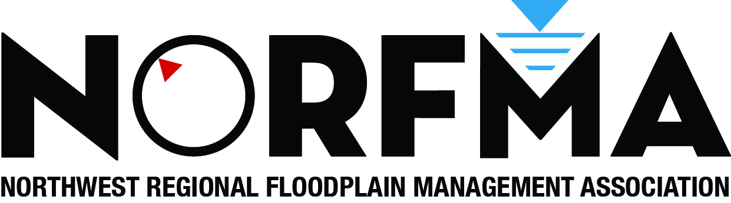
Scholarship
2013 Annual Conference
September 18-20 in Stevenson, WA.
At the Skamania Lodge

In a proactive manner and approach, NORFMA is reaching out to communities that participate in the National Flood Insurance Program to foster partnerships and information sharing. Communities that actively participate in NORFMA find that association with other communities in similar circumstances has benefits of finding common solutions to floodplain management issues. However, we recognize that time and budget restrictions, due to current economic conditions, may limit already small training opportunities of many communities, particularly those smaller communities in more rural areas. NORFMA would like to help by offering a scholarship for free registration to our annual conference which will be held this year on September 18-20th in Stevenson, WA at the Skamania Lodge. By attending the conference, participants will earn 12 continuing education units (CEUs). Registration also includes your 2014 NORFMA annual membership.
Eligibility:
- Staff of communities who are NFIP members.
- Must have at least partial responsibility with floodplain management duties.
- Not eligible to previous scholarship recipients.

Process:
Please email applications to
Hans Hunger, NORFMA Chair
hhunger@co.pierce.wa.us

The NORFMA Board will take applications through August 1, 2013 and after reviewing and selecting up to 10 for approval, will notify the selected applicants by August 9th .

Scholarship Application

Name:

Jurisdiction:

Confirm that Jurisdiction is NFIP member ___ Yes ____ No
Please describe your role and duties as floodplain manager for your jurisdiction

What support from NORFMA would you find most useful to your work?

